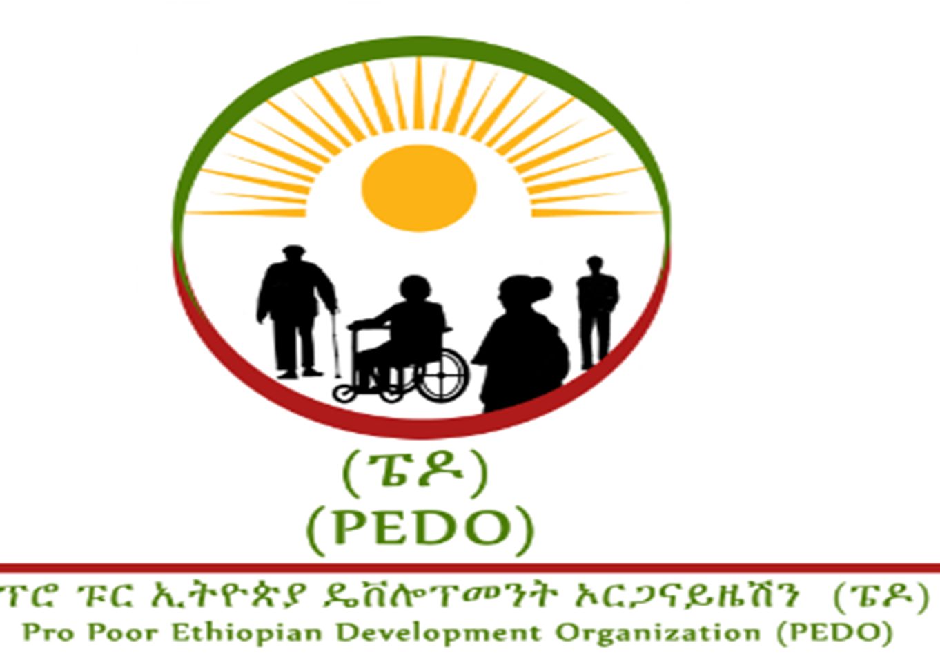

Performance report 2025

Table of content
Contents page
- Background……………………………………………………………………………………………………………………..2
- Accomplishments by program……………………………………………………………3
  - Orphan and vulnerable children and youth Support Program……………………….……3
  - HIV-AIDS and Adult and Youth reproductive health program………………………….7
  - Lively hood support program…………………………………………………………………………………….12
  - Community based structural empowerment program………………………………………….13

- Background
Pro Poor is non-governmental organization works to reduce vulnerability and marginalization of the disadvantaged groups of the community by empowering them to utilize their latent personal talents, to exploit the socio-economic and natural resources of the community without endangering the needs of the future generation. It gives an overriding emphasis for partnership and networking thus works closely with governmental, non-governmental, and private and community based organizations. It has long years of program implementation and grant management experience in partnership with different donors. In order to enhance the implementation process, it has well established system and procedures. It has got clear and less hierarchal organizational structure where the General Assembly is the highest governing and decision making body. It makes highest level decisions like approving the byelaws of the organization, annual plans and budget. In line with this the organization has adopted four major programmatic areas of implementation. i.e. community based structural empowerment program; livelihood support and promotion program; HIV-AIDS and Adult and Youth reproductive health program and orphan and vulnerable children and youth Support Program.
Thus under the above mentioned strategies during the previous one year, Pro-poor has implemented five different projects in Addis Ababa and Benshangul Gumz. The projects are in Benshangul Gumuz: in wonbera woreda in collaboration with MCMDO and various governmental stake holders and for the last 9 month on a project entitled: “Improving the health status of destitute women and youth & provision of socio medical service for victims of HTPs & GBV”; in Sherkole Woreda in collaboration with CSSP project entitled “Improving maternal health care behavior”. In kamashi and Agalomiti Woredas in collaboration with Tikuret Legumuz and CSSP a project entitled “Social and economic empowerment of vulnerable elders and persons with disability for sustainable development in the region”; In Assosa town in collaboration with KNH facilitator for change on a project entitled: Economic and social empowerment of selected destitute women. And in Addis Ababa in collaboration with CSSP a single project entitled: Improving youth resilience behavior against drug addiction specifically chat. As a result this report contains all the major activates that has been undertaken in the past years in accordance with their programmatic areas of implementation.

2 A annual accomplishments by program
The Organization has four thematic areas .Namely RH, HIV/AIDS program, OVC and youth Support program, Sustainable Livelihood Development program and Community empowerment program
2.1Orphan and vulnerable children and youth support
With the fund Obtained from CSSP though SYGE the following activities has been performed in 3 and5 woredas of Lideta subcity here in Addis Ababa
Launching workshop conducted: In order to familiarize the objectives strategies and the activities of the project A launching Workshop was conducted 03/12/2014 in Woreda 3 training hall. During the half day workshop 35 (20Male 15 feamale) participants represented from different pertinent stake holders living in two Woredas (3 and 5) of lideta sub city of Addis Ababa City administration.
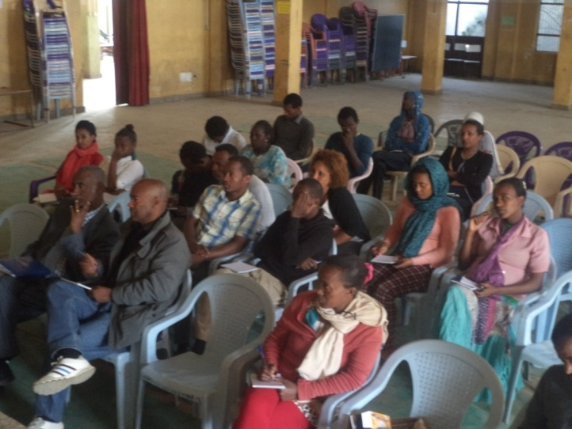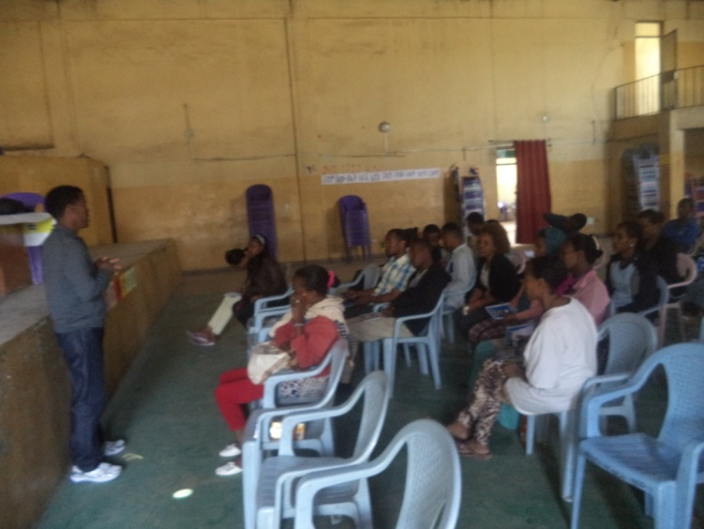Launching workshop being conducted
- Peer to Peer Educators training: Pro poor organized a 5 (Five )days Trainers of Trainers program on substance abuse for adolescent and Youth from 21-25 January 2015 at Addis Ababa , Lideta sub city woreda three Hall. 34(28 M nd 6 F) trainees participated in the training ,the trainees were drawn from Woreda 3 and 5 with recommendations from respective woreda project advisory committees.
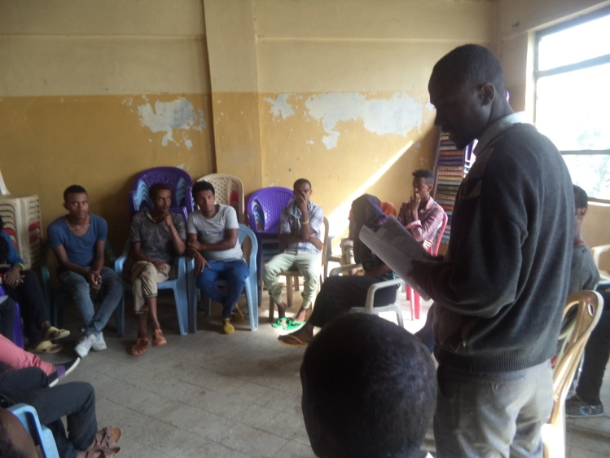
Peer to peer educators training
Peer to peer education sessions: These sessions were carried out by 33 Training of Trainers participates. In the reporting period 85 sessions were conducted by 33 peer educators.(17 in Woreda 5 and 16 in Woreda 3) one session has three hours time which is conducted in three a consecutive days (1 hr each).one session has an average of 8 trainees .During the reporting period 1342 have successfully attended and completed the training.

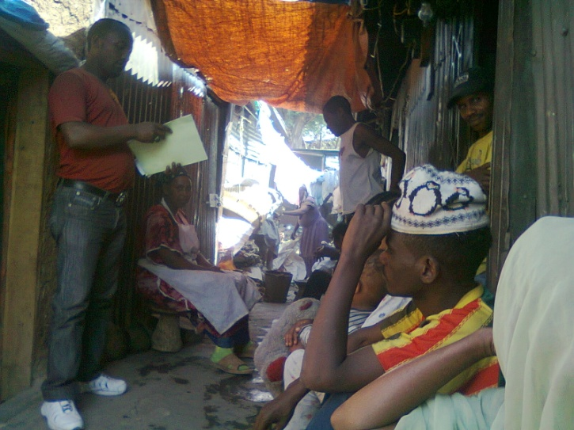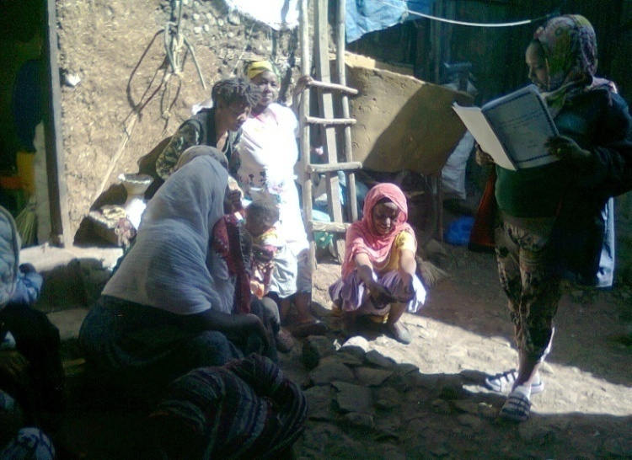
Peer to peer education being conducted

- Panel discussion On addiction: Half day panel discussion on drug addiction was conducted in august 15,at Woreda 3 hall .During the panel discussion 35 participants represented from woreda 3 and 5.

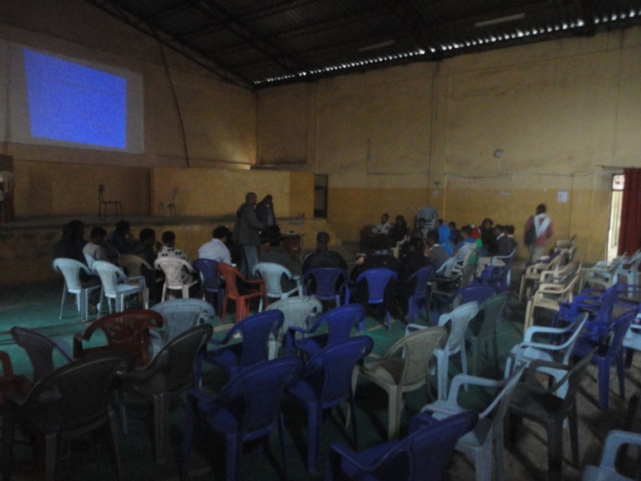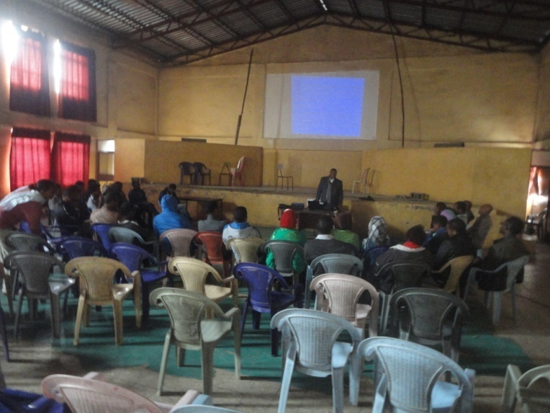
Panel discussion being conducted

- Material provision for youth centers: Based on the findings of participatory needs assessment conducted by pro poor together with concerned staff and youth leaders, we have identified the felt needs of each centers . As a result we have purchase and distributed 6 used computers for strengthening the IT room of woreda 3 and carambula for youth center of Woreda 5.
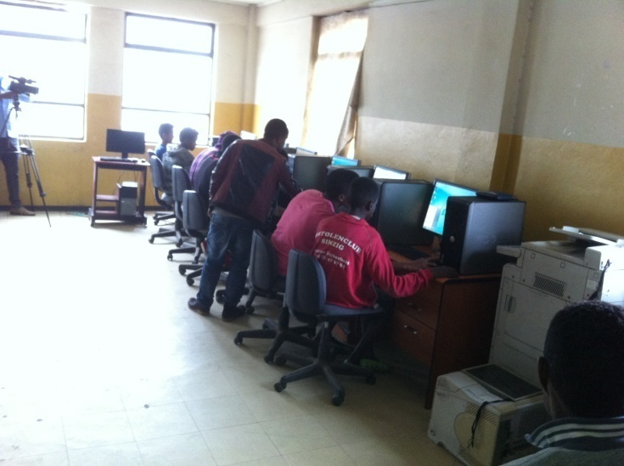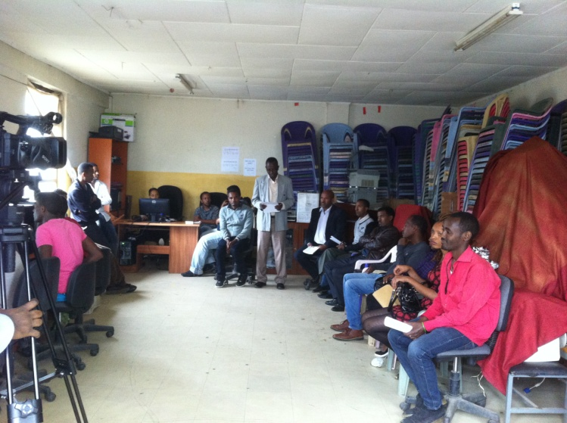
Material provision ceremony at wereda 3

- Production of IEC/BCC material: One of the activities planned to bring desirable behavior among adolescent youth was production and distribution of IEC/BCC materials such as posters, leaf lets and broachers’ .As per the plan the required IEC/BCC materials prepared and .
- Pannel discussion
  - Panel discussion On addiction
Half day panel discussion on drug addiction was conducted in august 15,at Woreda 3 hall .During the panel discussion 35 participants represented from woreda 3 and 5 .During the discussion a paper was presented by a resource person having substantial experience More over during the discussion adolescent youth who were victims of drug addiction has expressed their experience on how they started chewing chat its economic, social and emotional impacts and on how hey quiet .Finally participants recommended to record and document their practices related to chewing chat for teaching and learning process.

  - Entrepreneurship training:
From November 25, 2015 to November 27, 2015 for three consecutive days pro-poor in collaboration with woreda 5 & 3 women children and youth affairs office has given training on entrepreneurship training for 50 selected individuals from those woredas. Pro poor in collaboration with the consecutive woreda women children and youth affairs offices has used five criteria’s to select participants of the training. Those are: the person must be currently living in the Woreda; he/she must either should be a participant in the peer to peer education either as an educator or as a learner; a person free from any kind of drug addiction; a person who is not a beneficiary of other project by another NGO and a person who is willing to form a cooperative with other participants.
The training was conducted at the newly built woreda 5 youth center by Ato Tsegaye Abebe. The major topics covered in the training are:
- The meaning and importance of entrepreneurship.
- Entrepreneurship and success
- The importance of dreaming, planning, conducting.
- External barriers that could hinder us from achieving our dream
- How to be responsible
- How to look for opportunities in their environment and utilize them
- Endurance etc…

.
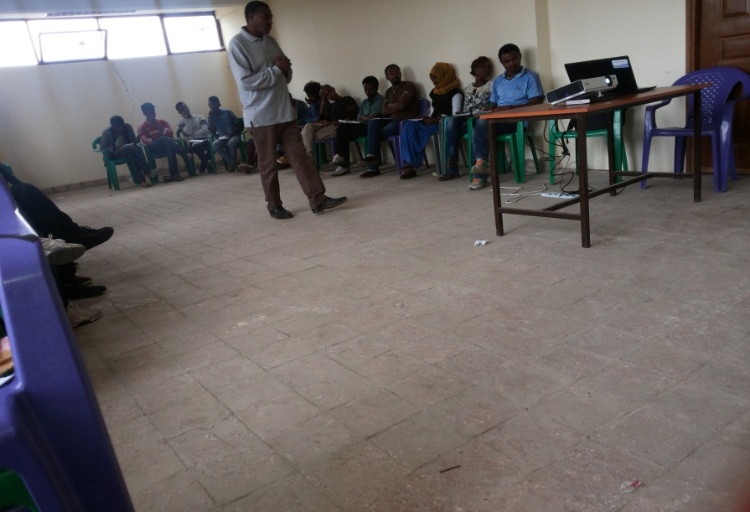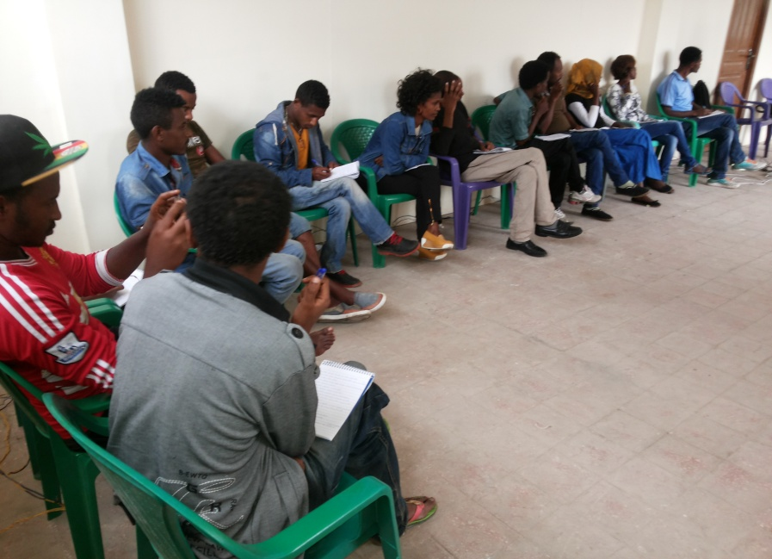
Figure 1 entrepreneurship training being provided

Youth Employment Provision of startup capital:
In order to promote behavioral change this service is provided directly to those who were once affected by chewing chat and show progress in terms of leaving this habit. And to youths who really are willing to get empowered and participate in group effort to lead a better life.
Thus through this particular activity we have been able to directly provide startup capital to 50 youths leaving in werda 3 & 5 of Ledeta sub city. The beneficiaries of this activity are mainly youths who have directly participated in peer to peer education session either by being an educator or a student. Additionally youths who have been given the chance to participate in this activity are the ones who have shown behavioral change by quitting drug abuse specifically chat. Further more all the beneficiaries have been given an entrepreneur training prior to the provision of the capital. Before transferring the startup capital to the beneficiaries pro-poor in collaboration with the Respective Woreda Women and children affairs office has helped the youths to form a small scale cooperative and open a bank account at respective woreda small scale credit association. Following this act 8 groups 5 in woreda 5 and 3 in woreda 3 consisting of 50 (46M and 4 female) youth have been formed. Then the next thing that was required from the formed small scale cooperatives was to choose the type of business activity that they want and write a business plan, memorandum of association create by law and fulfill all legal and administrative procedures . after fulfilling all the procedures The 8 cooperatives have been legally registered as legal entities having their own Tax Identification numbers (TIN) as well as registration certificate . Some of the IGA in which the cooperatives are engaged include tailoring ,selling and maintain mobiles ,petty trade embroidery and so on . .In order to facilitate smooth implementation of the cooperatives a memorandum of Undertaking (MoU) was signed between and among major stake holders mainly with ,Local Women, Children and Youth office ,Small and micro enterprise ,Youth representatives and Pro poor .As to the MOU small and micro enterprise was responsible to Facilitate vocational trainings in the respective Technical and vocational training centers ,provide working place and create market linkages .Based on the MoU one cooperative in woreda 3 engaged in electronics has received a working place in a very strategic place currently it is under maintenance as soon as they complete the maintenance will start doing business

2.2 HIV/AIDS and reproductive Health Program

Project Advisory Committees / PAC/ was formed: It has 8 members constituted from the woreda health office, woreda administration office, woreda health center, HEWs, Woreda WYCAO, Woreda Law enforcement office, and other key stakeholders. The main objective of the PAC Committee is to provide technical support to the project office activities of the project in accordance with its agreement signed among signatories
.
- Cascade of 5 days training for selected peer educators: 30 Peers educators selected from all kebels of the woreda got the training for five days. The main objective of this training was to aware community about Maternal and Child Health through peer education sessions.
- Facilitate cascading of peer education session through trained peer educators: The main topics of peer education sessions includes: Family planning, HIV/AIDS, ANC (After Natal Care), PNC (Post Natal Care), Safe delivery.
- Provision of trainings for HEWs to strengthen community dialogues: In order to strengthen community dialogues among communities, pro-poor provided three days training for 20 health extension workers from 19 different kebeles regarding Maternal and Child health.
- Build the capacity of HEWs through stationary materials (twice): The capacity building program was started by providing stationery materials for 20 health extension workers to take notes of all relevant activities during their work and make successful community dialogues and peer education sessions.
- One to five committee for mobilization identified and trained for three days: One to five health committees was identified with the intention of mobilizing and promoting maternal health care in Sherkole woreda. The major topics raised in this training are: brief introduction about pro-poor’s organizational background and the project that’s going to be implemented; how to support and conduct follow up peer to peer education sessions; why the one to five leaders are needed for the implementation of the project. And the need to include the community in the implementation of the project.
- Build the capacity of one to five leaders by providing stationary materials (twice): who are working hand in hand with Pro-poor to improve maternal health care, to combat harmful traditional practices, gender based violence and reduce sexually transmitted infections including HIV/AIDS.
- Arrange community conversations/dialogues by HEWs: Usually these kinds of conversations are conducted between ten to fifteen individuals in which one of them i.e. the health extension worker acts as a moderator of the conversation. The discussion usually focuses on HTP, GBV, STI including HIV/AIDS and family planning.
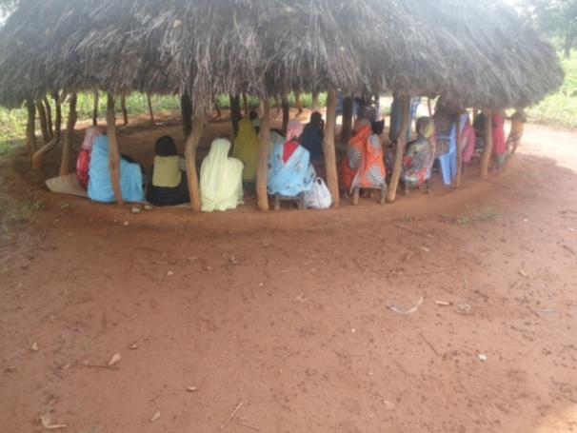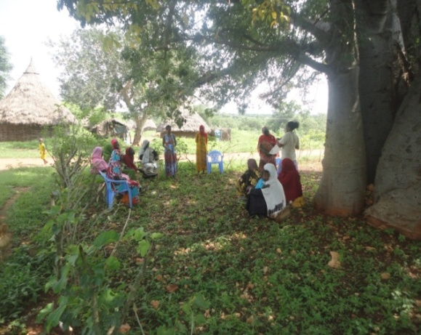
Community conversation being undertaken

- Strengthen the capacity of Sherkole health center through the provision of ambulance fuel and generator gas: Due to lack of transportation many mothers, even if they want to deliver their babies in health centers are forced to deliver their babies at their homes. As a result mothers are facing difficulties in giving birth. In some cases due to complications mother may lose their child or lose their lives.
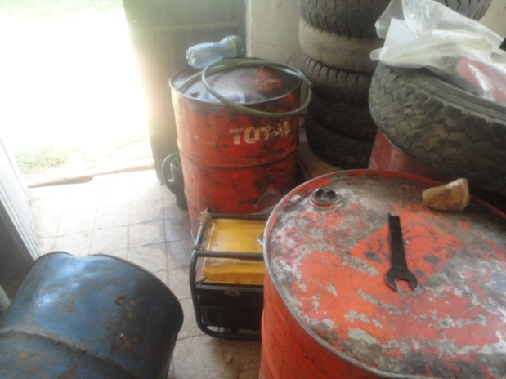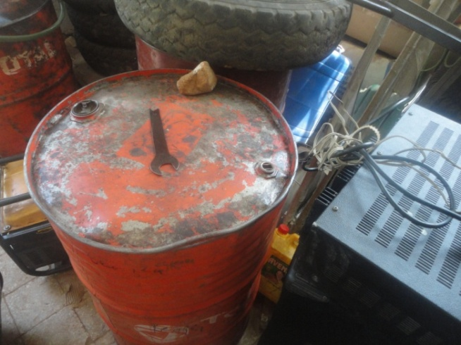
Generator gas and ambulance fuel
- Build the capacity of the committee through material and financial support: For this purpose we have conducted a meeting with the committee to decide on haw they are going to spend the 25000 birr provided by pro-poor.
- Facilitation of Community Wide Event: Two Community wide events were conducted in Sherkole town in different public areas. The main objective of this program is to create awareness about maternal health care related services to 10,000 community members.
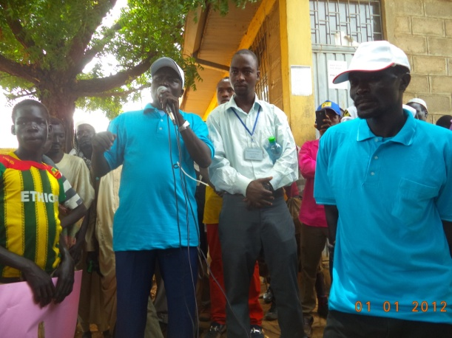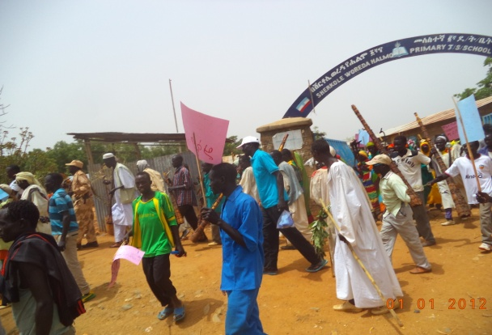
The wide event was launched by Ato Albukur,Vice head of woread
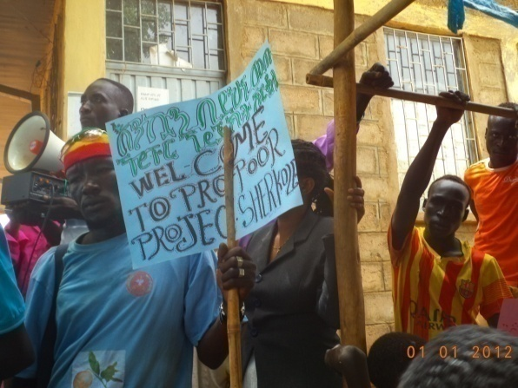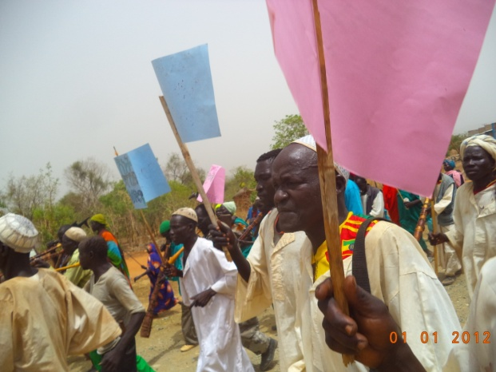
Partial view of the participant’s participants raising their slogans on paper

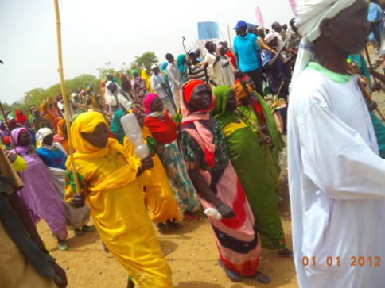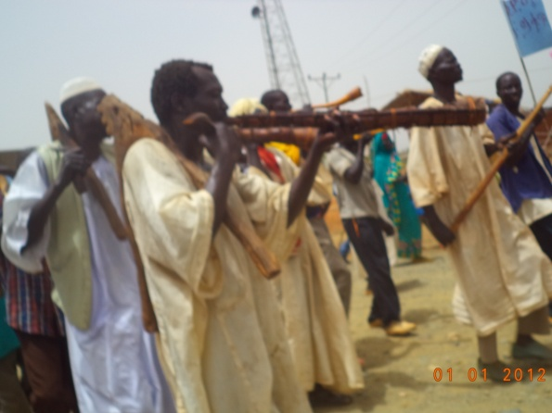
Partial view of the participants Traditional Music Were played during the event
- Quarterly Meetings: This program was conducted in Sherkole Administration hall in the presence of 35 key stakeholders from Health office, HEWs, woreda Administration and many others.
- Conducting home to home visits: through this activity we have reached more than 600 families.
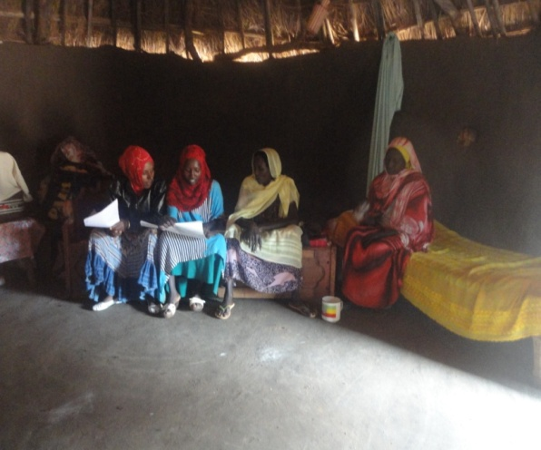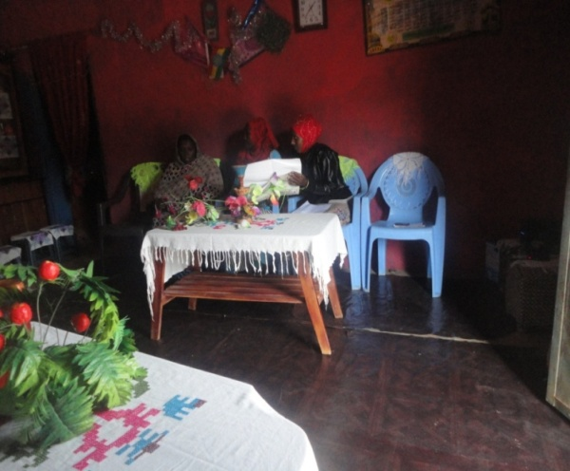
Home to home visit being conducted
- Provision of financial/material support for the sherkole health center: The intention of this support is to build the capacity of the health center trough material provision. As a result the health center was expected to identify and buy materials that can improve its service provision for patients.
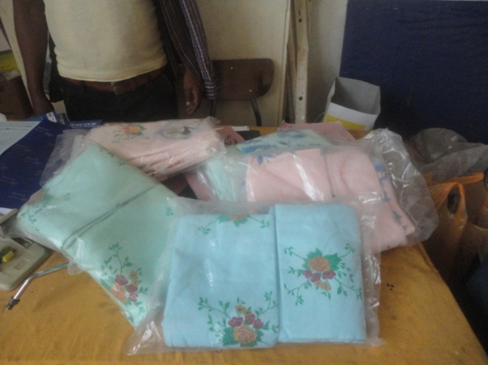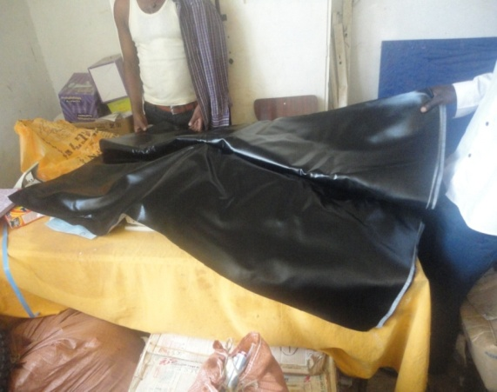
Bed sheet and raver sheet
- Behavioral Change Communication materials distribution: During the entire project implementation period pro-poor in collaboration with its with different stake holders has distributed 2000 browsers in Sherkole worda.
- provide training for HEWs on HTPs, GBV in Sherkole health center
- build the capacity of health center by providing training for health care professionals
- Provide awareness creation program by health extension workers: The awareness creation program was mainly conducted on market places by making the whole community its targets. During this time different ICC/BCC materials were distributed to the community. In addition different slogans were prepared that promote family planning, prenatal and postnatal care, fight against HIV were prepared and shown publicly and redden loudly using microphones in these busiest parts of the town
- Developing referral and records: 10 women from the families who get the home to home trainings provided by the four health care professionals get the chance of obtaining this service.
- Providing orientation for community structure: 10 elderly individuals constituted from 10 different kebeles, 5 religious leader and all members of the project advisory community were present during this orientation.
2.3 Lively hood support program
Individual income generating activity beneficiaries in Agalo Miti and Kamashi Woredas:
- Pro-poor has provided startup capital (2000 ETB) to 120 individuals 60 individuals at Kamashi(30 elders and 30 PWDs) and 60 individuals at Agalomati (30 elders and 30 PWDs) to them or through guardians i.e. their family member or close relative. All individual income generating activity beneficiaries has been provided with 2000 ETB by signing an agreement with them which indicates they can only use the given capital to income generating activities and not to use for consumption. So, most of them bought dairy goat, sheep, and calf as they agreed.
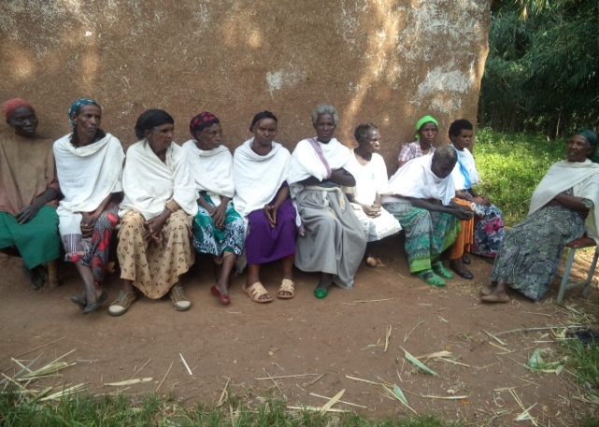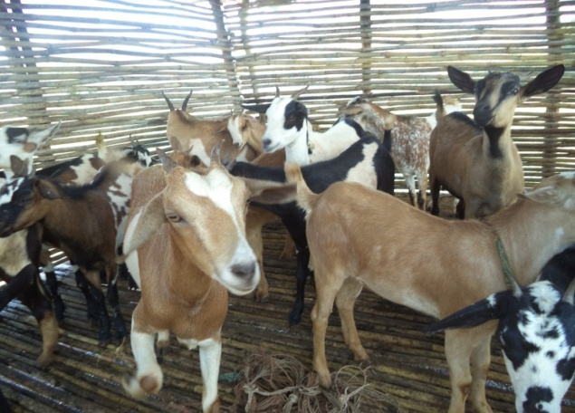
Individual IGAs
In wonbera woreda
.
2.4Community based structural empowerment program
1, MAHOCHA MIDIDA ELDERS CO-OPERATIVE
The co-operative was formed and named MAHOCHA MIDIDA ELDERS COOPERATIVES means elders working together union which is named by them. And the union has identified business sector to operation mill service to community and to generate income and subsidize themselves. It has twenty members which were selected by committee (its member are invited from different governmental stakeholders organization)which is formed for this purpose during selection of cooperative’s member from data base of social and labor affairs of Woreda office.
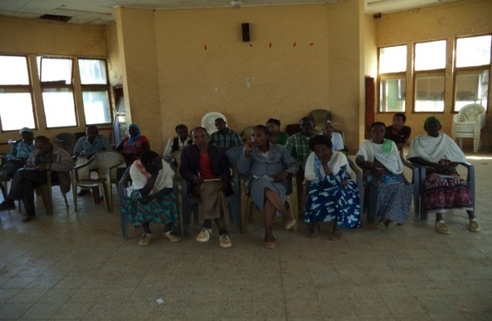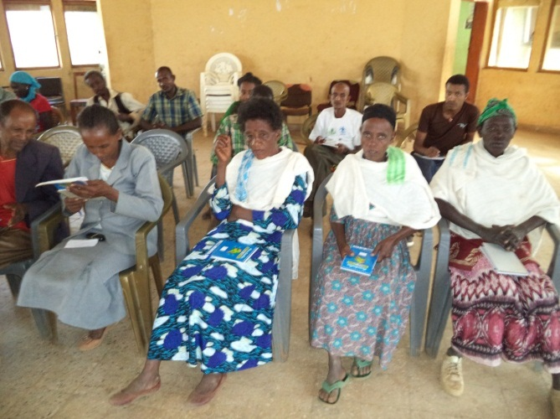
Members of the cooperative having a meeting

2 .KNH Project in Asosa
HIDASEW YESETOCH QUTEBA MAHIBER was formed before one year with a grant obtained from KNH facilitator for change which this grant will strength the technical and financial need of the existing SACCO groups in the project area. Pro-Poor will rearrange 100 destitute women in the project area who were already engaged in petty trade, small scale trading and others: and indirectly 10,000 community benefits from the project. Some of the major activities conducted are:
- Provision training on business planning for 36 women: small scale business planning, loan and saving types.
- Provision of startup capital for 40 women.
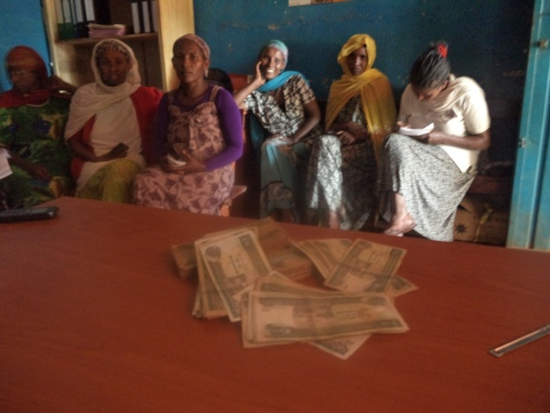
Provision of startup capital

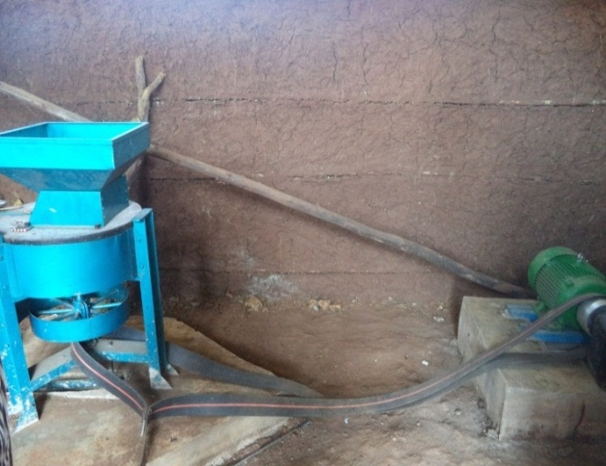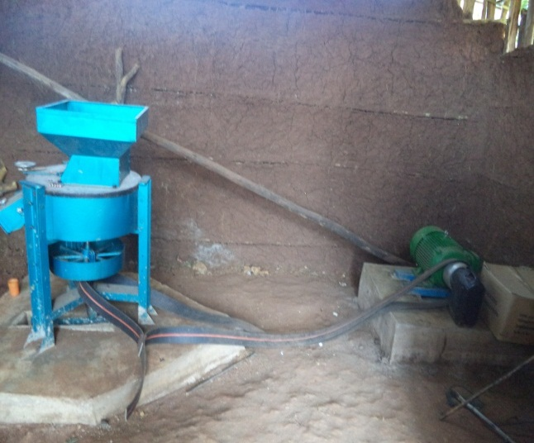
The grinding machine

2, ANDINET PWDs COOPERATIVE
Andinet PWDs cooperative has twenty members which were selected by committee (its member were invited from different government stakeholders organization) which is formed for this purpose during selection of cooperative’s member from data base of social and labor affairs of Woreda office. ANDINET PWDs COOPERATIVES means union of PWDs which is named by its members themselves. And the union has identified business sector to operate on retail shopping to community and to generate income and subsidize themselves.
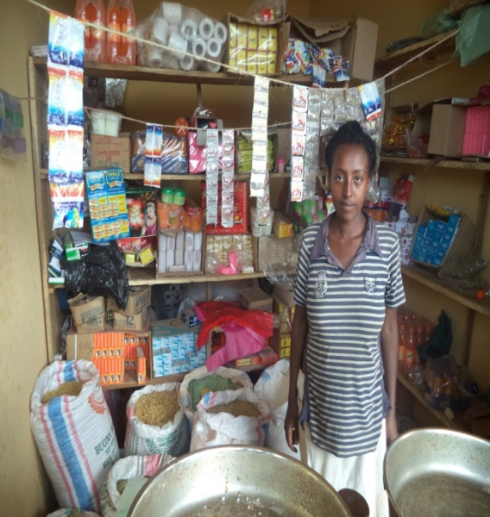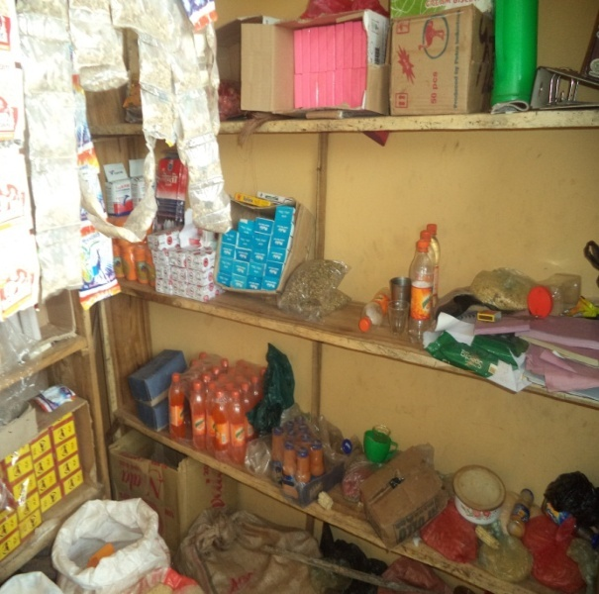
SHOOOP
3. MAKOSHA ELDERS COOPERATIVES
MAKOSHA ELDERS COOPERATIVES has twenty members which were selected by committee (its member were invited from different government stakeholders organization) which is formed for this purpose during selection of union’s member from data base of social and labor affairs of Woreda office.The co-operative has formed and named MAKOSHA ELDERS COOPERATIVES means beginner elders union which is named by them. And the union has selected business sector to operate on bee farming to generate income and to solve their financial and social problem.
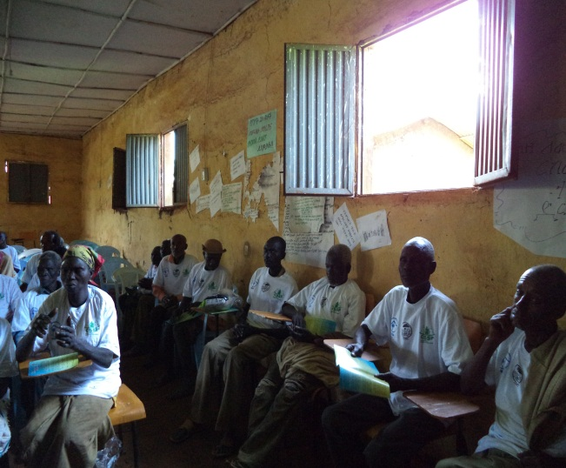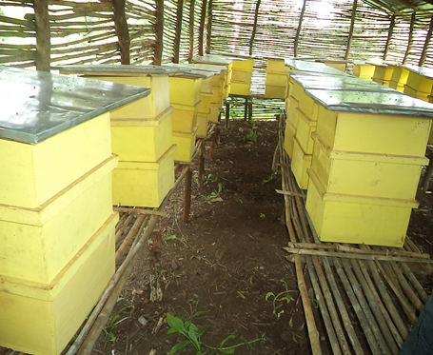
MAKOSHA ELDERS COOPERATIVES having a meeting
4 MIJIGIMA PWDs COOPERATIVES
The co-operative has formed and named MIJIGIMA PWDs COOPERATIVES means strong PWDs union which is named by them. And the union has selected business sector to operate on grinding mill service provider to community and make money and to solve their financial and social problem and live better life in community.
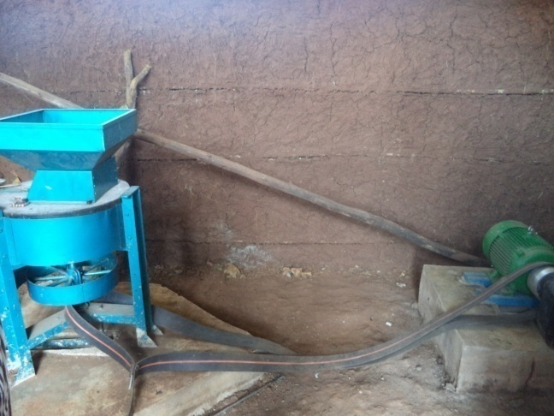
Grinding machine

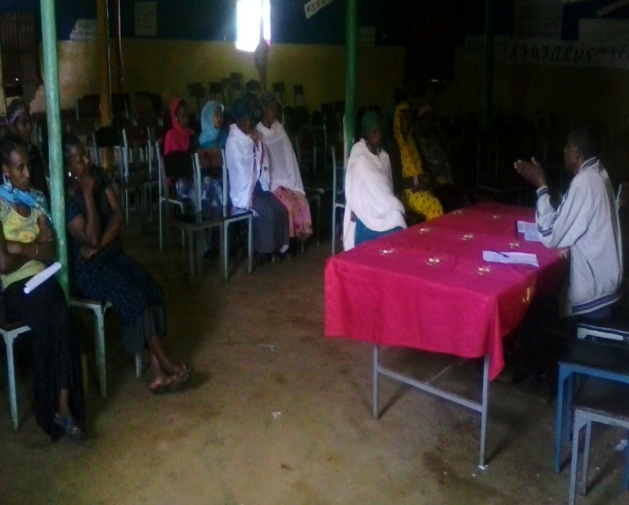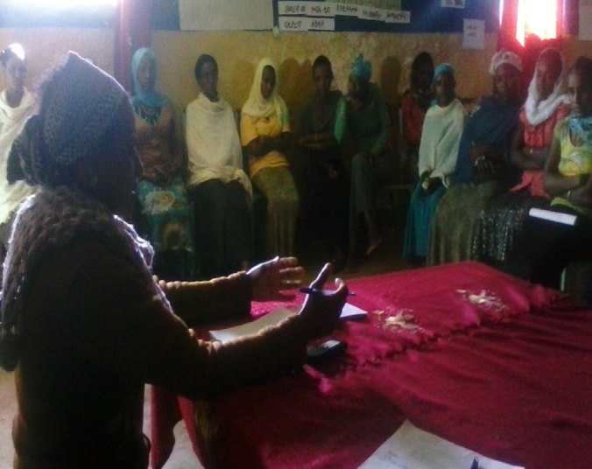

4 community empowerment

I. Procurement of material support for persons with disability and elders
J. Purchasing and handing over crunches, wheelchairs and eye glass:- through this activity we have been able to provide 5 individuals with wheelchairs in which one of them is a child, nine individuals with one or two side adjustable crunches and one individual with eye glass.
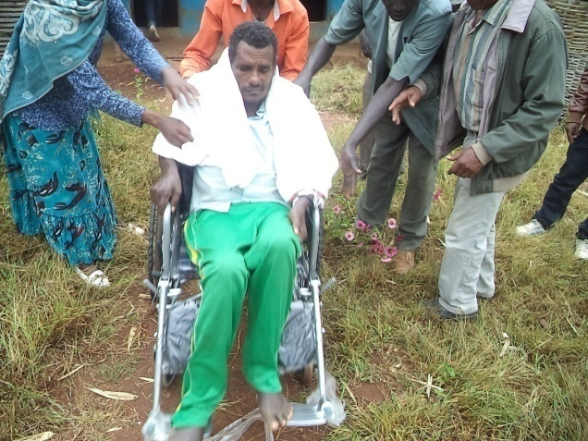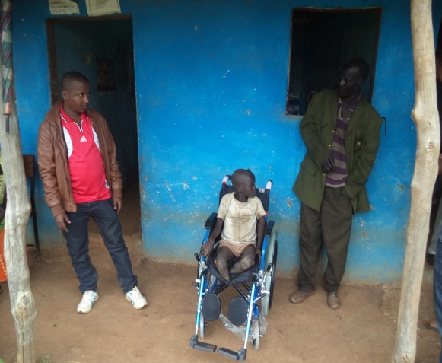
Fig.18 Material handing over cermenies
-27-
Tab.6 persons who are provided with crunches, wheelchairs and eye glass
S/n | Name | Type of material provided | Woreda
1 | Gunfire Minjena | Child wheelchair | Kamashi
2 | Kassa Nigusse | Adult wheelchair | Kamshi
3 | Mengestu Bulti | One elbow crunch | Kamshi
4 | Bake Gurumu | One elbow crunch | Kamashi
5 | Destalem Mosisa | One side Over arm crunch | Kamshi
6 | Agachik Godana | Bose sides over arm crunch | Kamashi
7 | Girma Getachew | Eye glass | Kamashi
8 | Gebabie Tasisia | Adult Wheelchair | Agalo Miti
9 | Tadelech Gutema | Adult wheelchair | Agalo Miti
10 | Abaya Dembilash | Adult wheelchair | Agalo Miti
11 | Zeritu Begizhino | Two adjustable crunches | Agalo Miti
12 | Lucho Azaji | Adult wheelchair | Agalo Miti
13 | Adula Mizhil | Two elbow crunches | Agalo Miti
14 | Godo Mulu | One elbow crunch | Agalo Miti
15 | Samuel Abun | Two adjustable crunches | Agalo Miti

K. Purchasing and handing over blanket shits to selected vulnerable elders and persons with disability in Kmashi and Agalometi It’s known that previously we have provided will chairs and crunches to vulnerable people with disability.After conducting that activity we have used the remaining budget to provide blanket sheet to 40 selected elders and disabled individuals. The individuals who were benefited from this service are selected by the Kamashi and Agalometi woreda labor and social affairs office. The handing over ceremony was conducted on Monday, December 14, 2015 by the reactive woreda administrators of the two woredas.
-28-
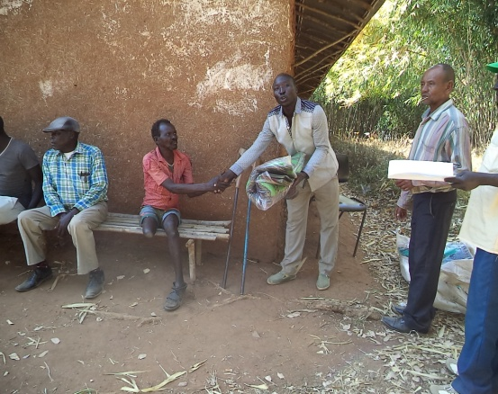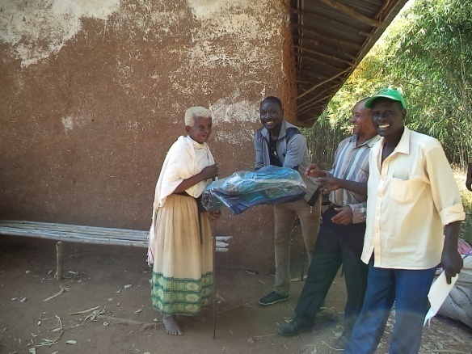
Fig.19 Handing over the blankets to beneficiaries
4.Community empowerment program
Celebrating world disability and elders day
Celebration of world elder’s day on Dec3, 2014 & 2015 in both woredas:- This day was celebrated twice in the past two years in the presence of key stakeholders from both woredas. The day was marked by mass mobilization against the negative perception of the community towards the elders and panel discussion was held at woreda level. During these celebrations in addition to the elders, representatives of governmental sector offices and woreda administration office hundreds of people from the community have participated. Usually these celebrations were facilitated by the joint collaboration of pro-poor, Tkiuret Legmuz Hizm Limat Mahiber, woreda administration and the woreda social and labor affairs office. For celebrating this day twice within the project implementation period we have used more than 2500 broachers, 4 six meters long banners, 500 T-shirts and the materials were distributed to the target groups and community at large to transmit massages. And on those behavioral communication materials primarily we have used Federal government mottos
- Leave No One Behind, Promote a society for All ;and
- Sustainability and age inclusiveness in the urban environment
Hand in hand with the celebration at the end of each long walk a panel discussion was held. The main topics covered during the panel discussions were:
- Presentation by pro-poor on the accomplishment of the project
- Listening to the reports of selected volunteers
- Reflection on the celebration day
- The progress report of the cooperatives and individual IGAs
-29-
- The overall administration of the formed SACCo groups
- The challenges faced by the cooperatives and individual IGAs
- The strengths and opportunities to be utilized for the success of the projects
- The roles that are expected to be played from government
- And finally blessings from the elderly

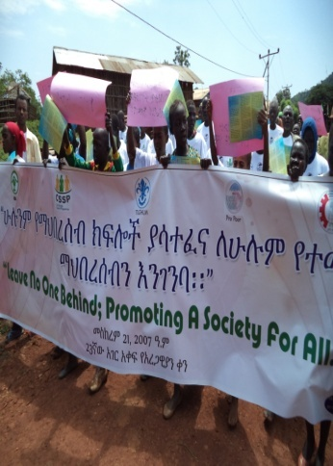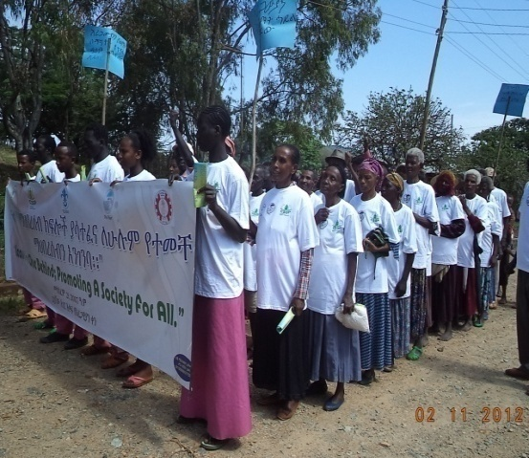
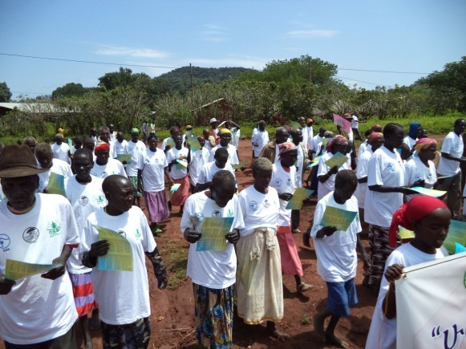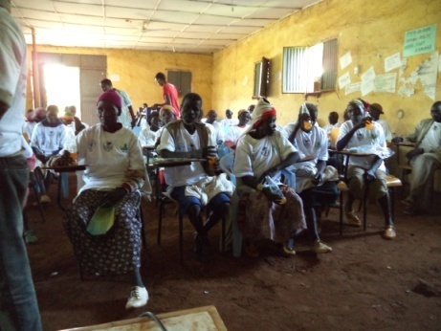
Fig.20 Partial view of the Celebrating international and national days of elders and PWDAs

M. Celebrate world disabilities day on Sep 21 in both woredas:- The world day of PWDs was celebrated in bright in the presence of key stakeholders in both woredas of Kemashi zone. The celebration was conducted on Sep 21, for two years. The celebration was all about creating awareness and advocating to the local community through IEC/BCC materials, Mass public announcement, to increase awareness and to avoid misconceptions of local communities towards persons with disability. For celebrating this day twice, we have used 4 banners, 600 T-shirts and more than 2500 brochures which were distributed to the target groups and community at large. Different stakeholders have participated in these days

celebrations. The public announcements were all about positive attitude towards the people with disabilities at all level and to call out the community to participate on the celebration. During the advertisement that we made and through the behavioral communication materials we use, we have disseminated the Federal government motto twice i.e. “Enhance Technology for PWDs to bring sustainable development.” And “inclusion matter access and empowerment of people of all abilities”. At the end each program panel discussions were conducted regarding the perception of the local community on the following topics in the presence of key stakeholders in each woreda:
- Disability doesn’t hinder hardworking
- Let us enhance PWDs with technology for sustainable development of the nation
- Let us protect PWDs from physical as well psychological offences
- The progress made by the implementation of the project
- The strengths and weakness shown by the stakeholders during the implementation period.
- The roles to be played by governmental stake holders.

This particular activity have two components namely:
- Preparation and Erecting of bill boards
Four bill boards were constructed and erected on Friday December five and Saturday December six in both kamashi and Agalaometi woredas. The bill boards were constructed in market places where many people pass by to see them easily.
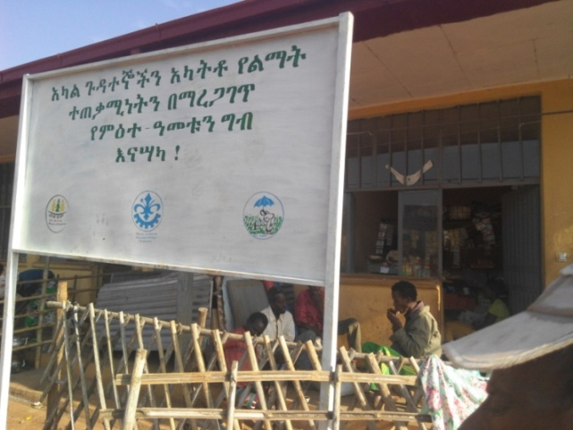
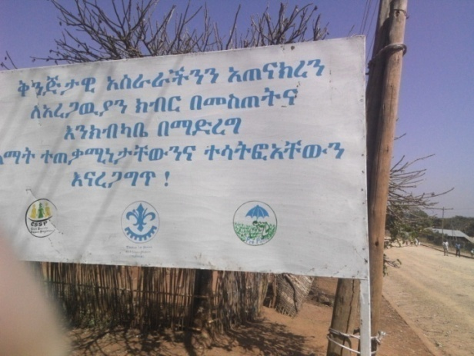
fig.14 sample billboards
- Community dialogue
The 2nd community dialogue was conducted on November 11 and 12 2015 In Kamshi and Agalo mati woredas. Fifty five individuals represented from sector offices, beneficiaries and social labor affairs have participated. The major discussion points of the dialogue were the communities miss conceptions towards elders and persons with disability. At first the project officer and representatives from the woreda labor and
-24-
social affairs office gave a very brief explanation about the issues and its various manifestations by giving some examples that are observed in the woreda. Then after, participants were given opportunity to give their opinions and questions about the issue. Some of the feed backs raised by the participants were: the government offices are doing nothing when elders and people with disability face problems and seek help; awareness level of the community is very small and the government hand in hand with NGOs should work to raise awareness; even if in theory the government says it gives emphasis to elders and disabled individuals the idea is not observed being undertaken; what is going to happen after the project phases out and acknowledgement from the participants to the project activates so far.
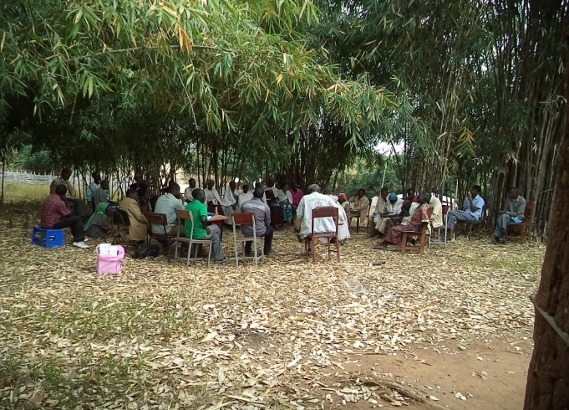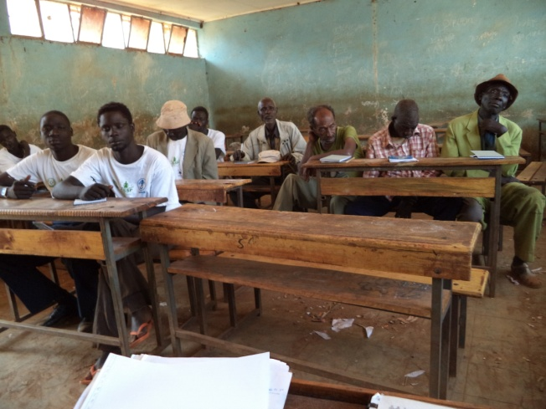
Fig.15 Community dialogue being held at Kamashi
- Providing training on small scale business development skill and practical 3.6.1 Vocational training:- Pro-poor in collaboration with the Agalo Mati and Kamashi Woreda labor and social affairs office and Kmashi Technique and vocational training collage had been conducted. With this activity in motion 30 persons with disability were selected from Agalo Mati and Kamshi woredas were able to get bamboo work. The participants of the training are mainly persons with disability within the two woredas but since the type of training requires physical ability and some level of educational background some of the chances have been given to elderly individuals. In relation to this in order to create a chance transparency and accountability, all the participants of the training were selected by a committee. After giving this training trainees not only get the knowledge about bamboo work but we have also created the opportunity for them to make a -
saving and get loan from the Kamashi Zone loan association. Furthermore this activity is done at the end of the project phases out, the two woredas labor and social affairs offices took full responsibility to facilitate & organize the training.
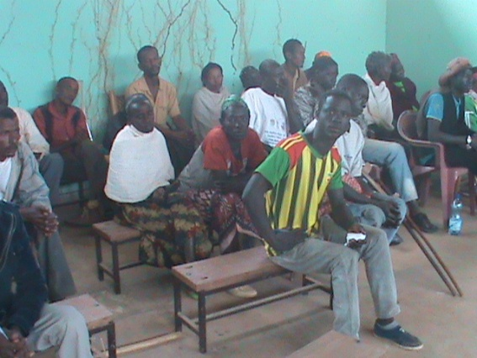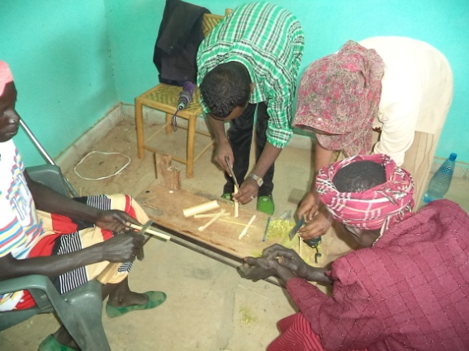
Fig.16 Partial view of the training being conducted

.

2.5 organizational capcity building program Capacity building
Under this topic three major activities were carried out namely Purchase of Office Equipments staff recruitment/training and system development

V. Staff recruitment
With the grant obtained from different donors including , CSSP, MCMDO, and SYGE the organization has recruited 4 project officers project manager and 2 nurses .One project officer, is working at head quarter in Addis Ababa while the remaining staff are working in different project areas(2 nurses Sherkole and Project manger Wombera). Currently pro-poor has 11 employees of which 6 of them are working in the head office while the remaining 5 are working in different project areas. Furthermore the organization has over 70 volunteers supporting to the respective project officers in different sites.

VI. Purchase of office equipments
With the budget obtained from different donors the organization has purchased and distributed to different project sites, The office equipments include but not limited to Office tables and chairs , lap top computers ,1 digital cameras, desk top computer are a few to mention

VII System Development
During the reporting period the organization has developed the following systems
Web site
Broad band internet
SPM (strategic Planning Management )2016-2018
HAP (Humanitarian Accountability partnership)

VIII. Manual development
With the fund obtained from different donors the organization have developed peer to peer training manuals brouchers, posters having tailore made messages about reproductive health issues

8. Resource mobilization/fund rising
During the reporting period the following 6 project proposals were developed and submitted to different funding agencies That is,:
- 1KNH- Proposal development
- 2 proposal to FMOH
- 1 proposal to CIDA
- 1FSR(ICCO)
- 1EU
- 2 CCRDA
- 1 CSSP
- 1 MCMDO
Out of which 2 small grant proposal which was submitted to SCMDO and CCRDA was awarded, 2 proposals submitted to KNH and CCRDA is not disclosed while results of the remaining 5 proposals submitted to different donors. were not positively considered
.

X. Challenges
- Scarcity of funds to the expand and sustain our programmes and recruit adequate and qualified staff
- Scarcity of sufficient material and financial resources to support the staff capacity.
- Lack of sufficient volunteers for effective implementation.
- Lack vehicles to transport logistics to the project areas from head quarter
- Staff turnover sue toned of better salary

XI. Plan Vs Achievement
 | Plan Vs Achievement is indicated in the following table (January1, - December 31,2013)
 | Project title | Planned | Achieved | %
1 | 1.Livelihood Support Program
 | 1.1 Training for Selected destitute women on Business planning development and leader ship for the new and old Members of the Tokuma and other associations | 60 | 40 | 80
 | 1.2Providing Star up capital to 5 cooperatives | 100 | 120 | 100
 | 1.4 Livelihood promotion of rural households through bee hives | 20 | 20 | 100
 | 1.5 Social and economic support of PWD | 60 | 60
 | 1.6 Support for Elderly | 60 | 60
2 | 2. RH/HIV/AIDs Program
 | 2.1 Cascade peer education sessions in schools and out of schools such as to youth canters ,DSTV rooms ,etc | 1400 | 1348 | 100
 | 2.2 Develop tailored IEC/BCC RH message for youth | 3000 | 300 | 100
 | 2.3 Convey messages on consequences of RH through BGR TV and FM | 2 | 1 | 50
 | 2.4 Planting bill board that has messages on PWD and Elders | 2 | 2 | 100
 | 2.5 Referral linkages for the Provision of special support for AYRH, FP, PMTCT, ART and conduct VCT, STI test. | 1000 | 820 | 85
3 | 3. Community Empowerment Program
 | 3.1Awarness raising workshops o n effects of Chat | 50 | - | -
 | 3.2Strengthening Youth recreational canters at Woreda 05 and 03 woreda.
 | 3.3 Strengthening of health facilities and Youth canter in Assossa | 5 | 2 | 75
4 | 4. OVC and youth Support Program
 | 4.1 Job Creation and establishment of business undertakings for youth in Babasi |  | 0 | 0
 | 4.2Build capacities of Health facilities and Youth canters by providing material support | 5 | 2 | 75
 | 4.3Provide training for Youth club leaders Health care providers on YFS | 30 | 15 | 50
 | 4.4 .5Train Influential community leaders ,FBOs, CBO and PTAs on AYRH issues | 40 | 1 | 100
 | Fund raising /resource mobilization | 12 proposals | 9
5 | 5. Administrative costs
 | 5.1 Develop and up organization Strategic plan ,Procurement Manual, Personnel Manual ,Financial manual | 4 | 4 | 100
 | 5.2 Monitoring and Evaluation | 3 | 3 | 100
 | 5.3 Purchase of different office equipments | LS | - | 33
 | 5.4 Purchase of vehicle | LS | 0 | 0

XII. Conclusions
It can be said that during the reporting period some of the planned activities has been performed 100%, Some of the activities have been performed more than 50% and few other activities are performed less than 50% of the annual plan while some activities such as development of manuals was performed 33.33% due to financial problems. As far as fund raising is concerned 100% of the planned activities have been achieved. This shows that one of the crucial problems of the organizations in relation to limitation of budget is being addressed.

