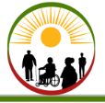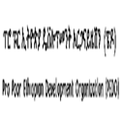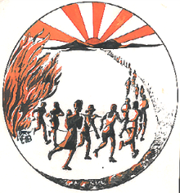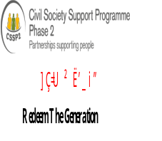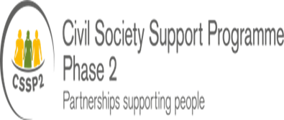

Pro Poor Ethiopia Development Organization
(PEDO)

Annual Reort
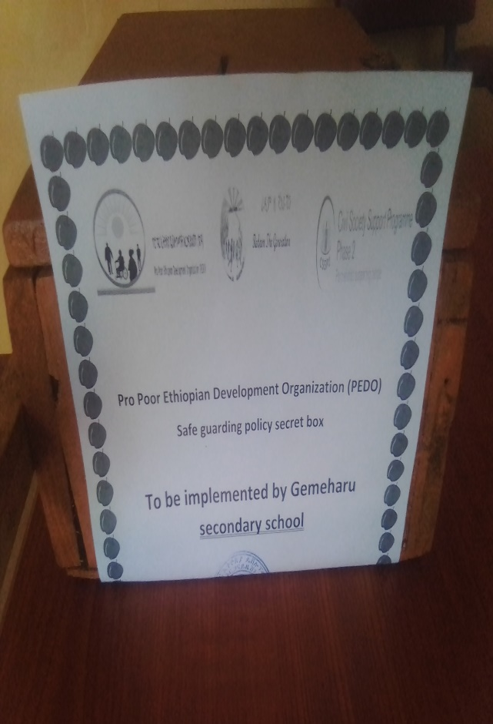
Safe guarding policy secret box

April 24/2021
Assosa,Ethiopia

Executive Summary
Pro- Poor Ethiopian Development Organization (PEDO) was established in June 2003 with the vision “regenerating, hope and self-esteem” for the hopeless and the disadvantaged sections of the community. Based on the new CSO law, it was reregistered as Ethiopian Resident Charity Organization in October 2009 and renewed it registration certificate in March 2016 active until 2020. It is implementing a project entitled as Youth Leadership and Engagement Access for Development (Y-LEAD) in BensishangulGumuz Regional State of Assosa town administration woreda1 &2. The project duration is from 01 November 2019- 30 April 2021.

Objective
- General Objective:
- To contribute to the general wellbeing of youths.
- specific objectives:
- To advocate policy makers and stakeholders for the approval of the draft proclamation for khat control and for establishment and strengthening of services for victim and survivors ,
- To identify and establish start-up business for vulnerable and survivors of substance abuse ,
- To improve stakeholders and community engagement on the adverse effect of substance abuse among the youth and the society people to amplify their voice to government, policy makers, and community members so as to demonstrate positive change agents,
- To capacitate and support young people to be active citizens and engage in peace building, conflict prevention and violence protection,

Plan Vs Achievement
1.1. Conducting evidence based research
PEDO have been Captured/collect evidence on the adverse effects of substance abuse on young people a case study of targeted project area of Assosa town in collaboration with Aha Consultation P.L.C. This helps us to present the finding of the research to the general public and policy makets about the adverse effects of substance abuse on young people:

1.2. Conduct action research about youth and peace in collaboration with youth clubs to identify their common concern and increase engagement (TBD)
We started a proses with Assosa University to conduct action research to identify their common concern and increase engagement at peace building and conflict resolution as well ass social and economic participation at the two woredas Assosa ton administration of 3 selected ketenas.
1.3.Conduct participatory video trainigandconsultation meeting
We have been conducted participatory video training and consultation meeting how to establish addiction rehabilitation center, to prevent the effect of khat and it’s associates on youths and the general public as well as how to ban khat and it’s associate local laws. During the training , male 15, female 10 t0tal 25 participants attended at the training program july 27/2020. were We established addiction rehabilitation creation committee at Assosa town administration level. The committee has 7 male and 2 female a total of 9 members from different concerned sectors, The committee is by Assosa town administration vice mayor. The committee prepared an action plan .

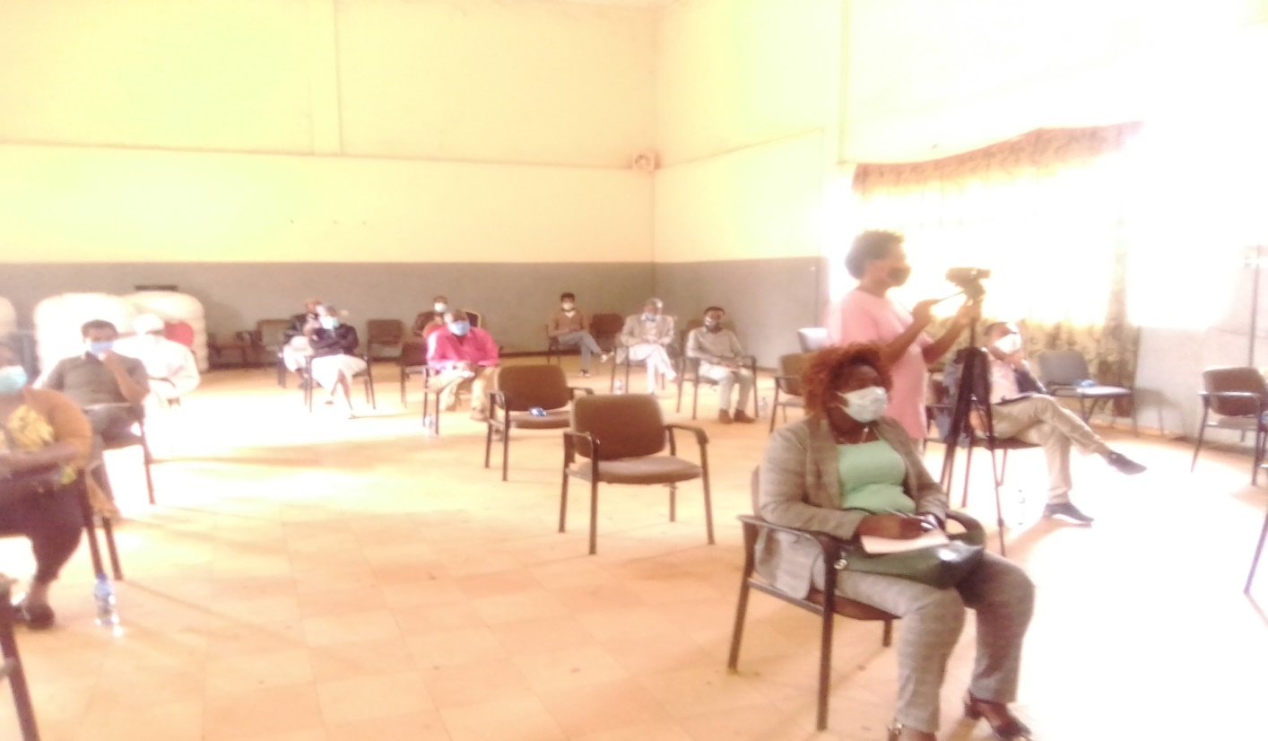
Image 1. PV &video production training

1.4. Establish addiction rehabilitation service improvement center ( Committee Joint action plan
- were We established addiction rehabilitation creation committee at Assosa town administration level . The committee has been prepared joint action plan to conduct the following activities,
- To improve youth recreational centers & addiction rehabilitation c enters
- Adopt community by laws of ckat and associate drugs
- To minimize the negative effect of ckat and associate drugs
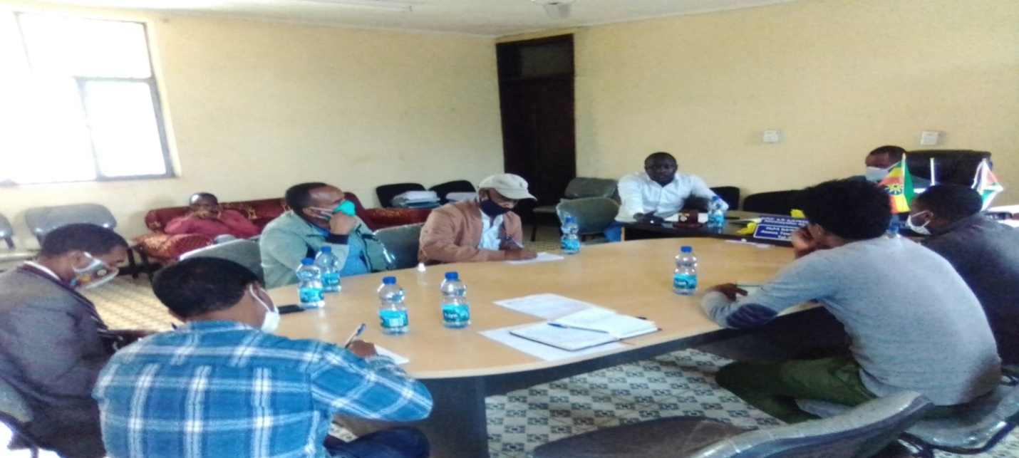
Image 2.addiction rehabilitation committee members

1.6. Support youth art clubs and associations to engage on prevention and preparedness against the spread of COVID 19 among the general public
Awareness creation was conducted by Zumbara youth vision association and Zumbara youth art club on the influence of khat on prevalence COVD19 as well as peace building mechanisms at Assosa bus station, market places, crowded place where khat and other drugs are mostly used. The awareness creation was conducted by using banners, musicMontharbo, mic , video camera and different slogans. During the awareness raising program male 20, female 8 total 28 art club members were participated. In addition to the art club members Assosa town administration youth office head and Assosa town administration police members were attended during the program.

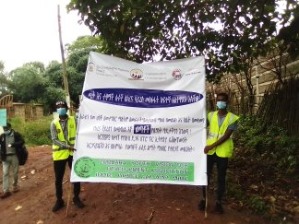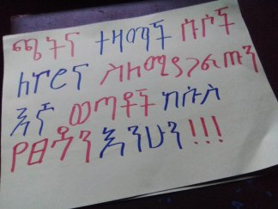
Image 3.awareness raising banners by Zumbara art club

1.7. Safe guarding policy implementation
As of PEDO we have prepared and erected secret boxes, safe-guarding policy focal person, Safe guarding policy guide line, Consent letter, and contact information in PEDO project office. Under the safe-guarding policy we also have formed a committee to open secret boxes every week. In addition to this, PEDO staffs have signed code of conduct as well as we are creating awareness about the importance of safe guarding policy.
Based on this we have been prepared safe guarding policy consent form to be signed by our stake holders when they are coming to our project office and when visiting our activities and our volunteer youths. This is used to prevent the violation of our safe guarding policy and it is also important to implement the safe guarding policy. We check the safe guarding policy every Monday at the end of the week. This is done by our safe guarding policy focal person and the committee evaluates weather there is violation of rights at the project staffs or our beneficiaries and the, if the case is managed by the committee it will be managed by the committee or if the case is above the mandate of the committee it will be referred to the board of the organization to be managed.
  - Conduct Regular discussions on Legal, Policy Frameworks, and practice at national and regional levels will be conducted

Pro Poor Ethiopia has been conducted regular discussions on legal, policy frame works and practice at Assosa city administration on 24/02/2021. The discussion was focused on the community by law adoption and implementation at Assosa town administration. The discussion was conducted by JAP committee members, government officials, influential persons youth association members, khat venders, women association members and religious leaders and community leaders. During the dissociation session male, 37, women 25 a total of 62 participants were attended or participated. The discussion was led by Assosa town administration council speaker.
- 9 .Establish appropriate safeguarding mechanisms to encourage all members of clubs to report suspicions of sexual exploitation or any other abuse.

We have been established appropriate safeguarding mechanisms to encourage all members of club to report suspicions of sexual exploitation any other abuse. This was done by giving safe guarding policy and implementation strategies as well as guide lines to our volunteers, Zumbara youth art club, selamber primary school and Gemaharu secondary school directors, gender club representatives and students from March 10 to11/2021 . During the training program male 23 female 17 a total of 40 training participants were attended. In addition to this we have been distributed to two schools and Zumbara youth art club a total of three safe guarding policy implementation suggestion boxes.

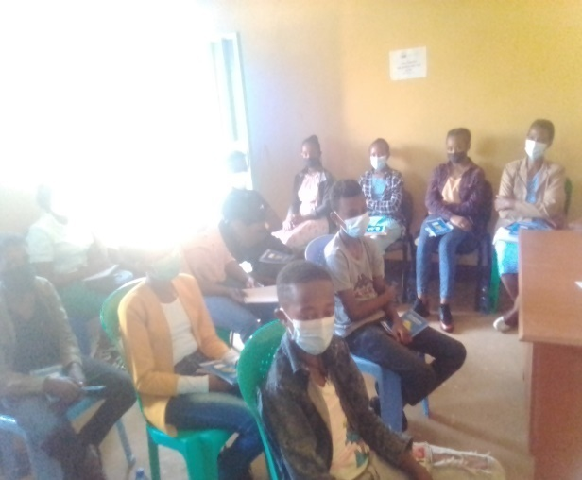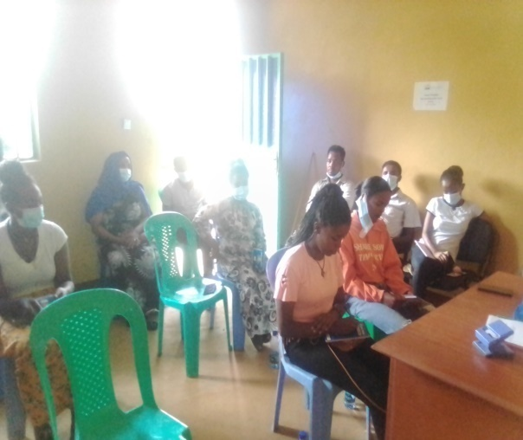
Image 5.safe guarding policy training participants
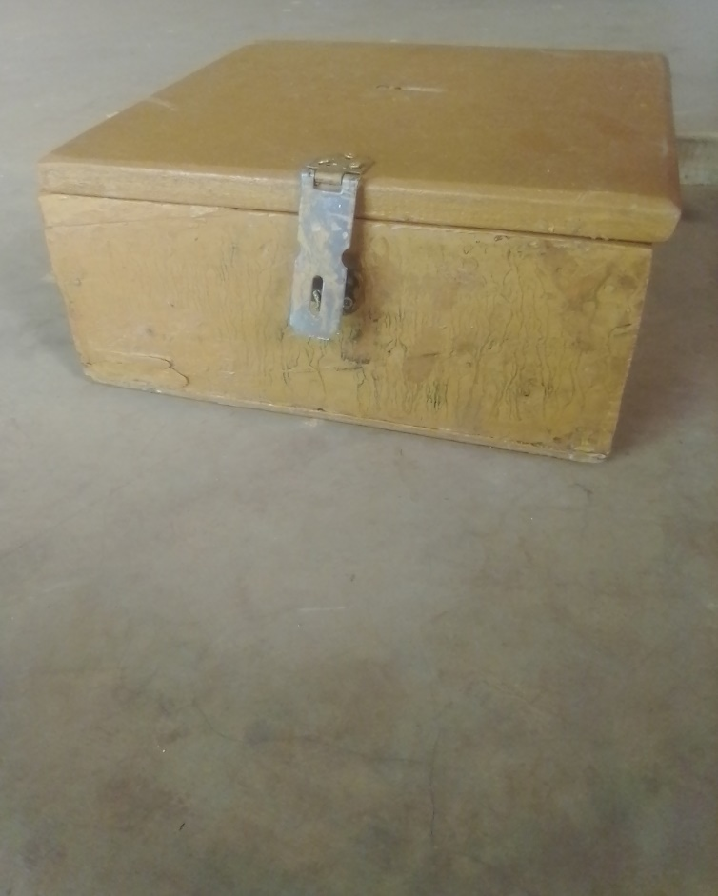

Imege6.Safe guarding policy suggestion box delivered to Gemaharu secondary school

- 10. Provide active citizenship training for 100 vulnerable street children, PWD and survivors of substance abuse

Providing active citizenship training for male 61, female 39 a total of 100 vulnerable street children, PWD and survivors of substance abuse was PEDO’s the core activity plan. Based on this we have conducted active citizenship and social action training for 5 days. The training participants were selected from Assosa town administration of woreda 1 and woreda 2, 10 kebeles. The selection and the targeting prosseswas done by each kebele administrators based on the selection criteria and gender mainstreaming proses. After the training was conducted the each participant was conducted community mapping from their kebels. When we evaluate their awareness the post test result indicates the awareness of active citizenship is more increased than the previous one.

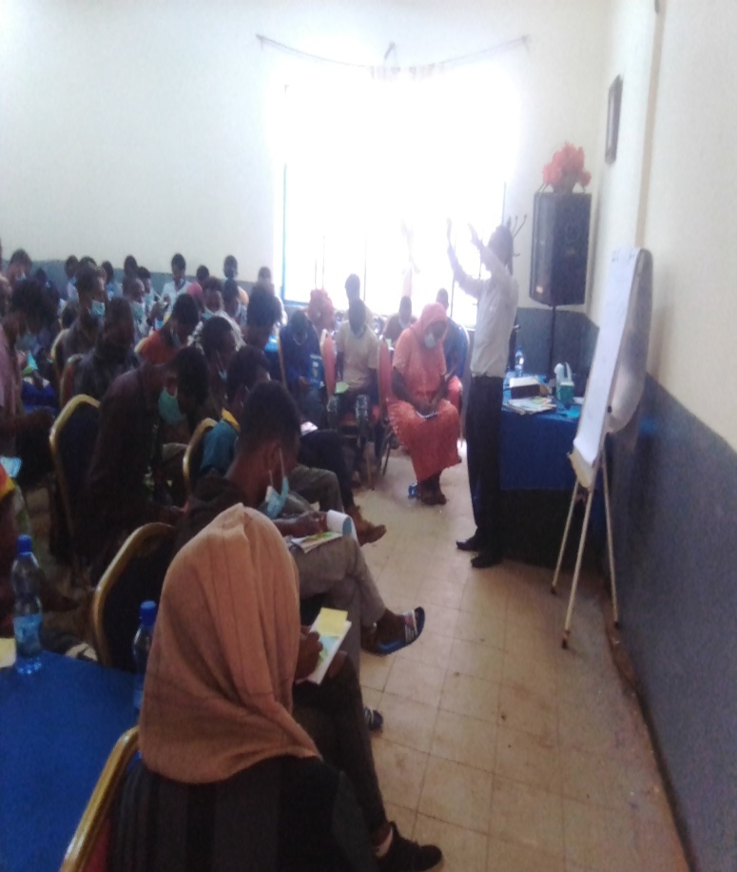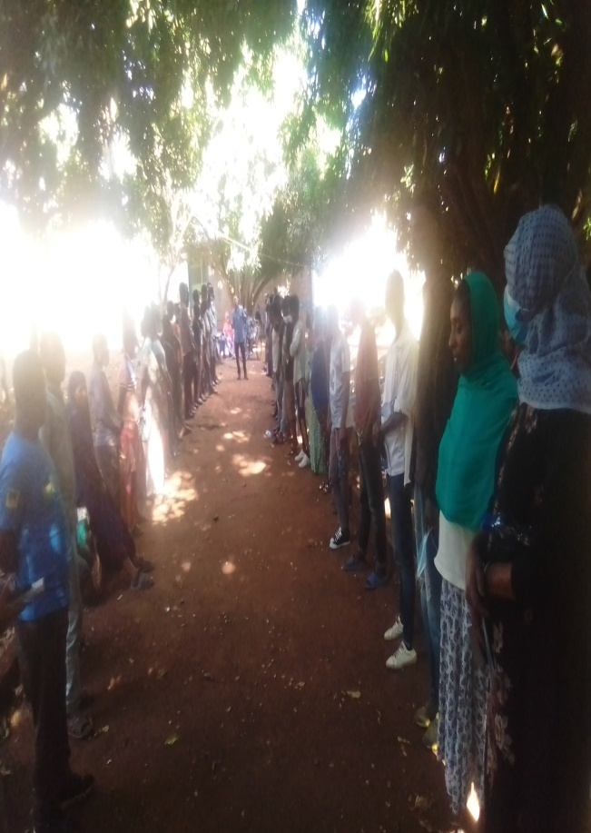
Image 7.Active citizenship training participants

  - Call for art competition at the regional, zonal and district level, (initial activity Organize, one annual youth festivals at regional, zonal and district levels to voice their issues, interact and share experience among young people)

As of Pro Poor Ethiopian Development Organization we have been done art completion advertisement by using different announcement and advertisement strategies. Based on we have been conducted advertisements by using car, montarbo and advertisement at all parts of Assosa town administration and Assosa university. In addition to car advertisement we have been also posted the art completion from different public destination, schools, Assosa University and youth recreational centers and also different offices to be present for 20 days.
Currently the announcement and advertisement air time is already finished. Based on this we have registered male 25, female 7 total 32 competent were registered. From the registered competent we have received male 7, female 3 a total of 10 competent were delivered their pictures to Pro Poor Ethiopian Development organization (PEDO) project office.
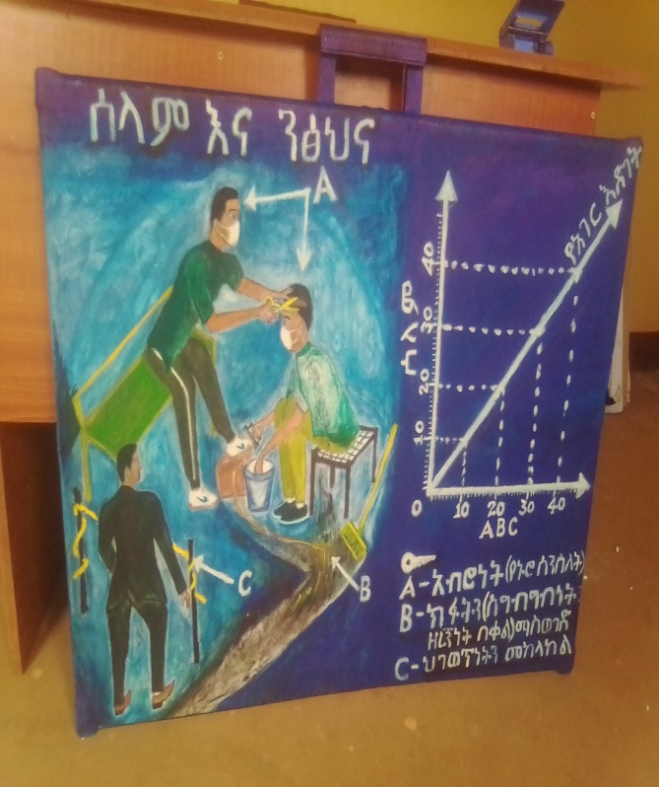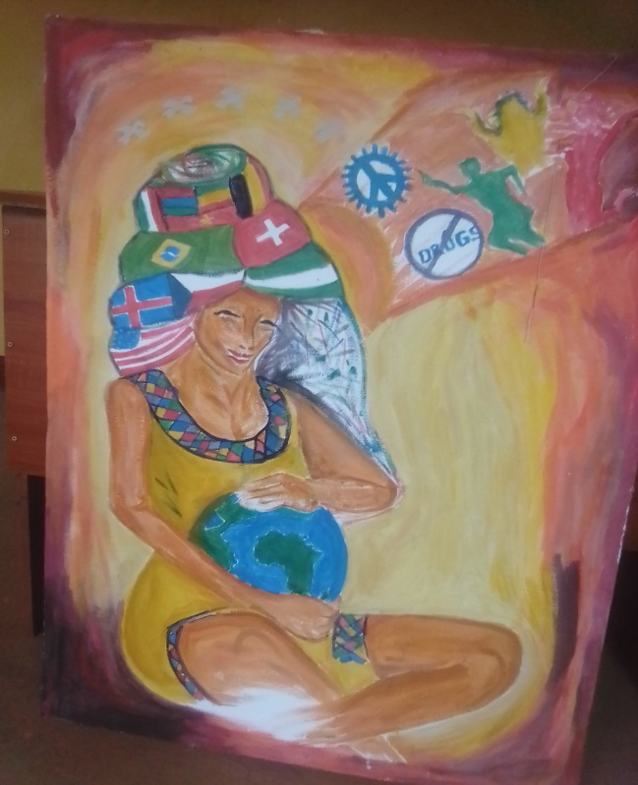
Image 8.Art competition sample pictures

  - Conduct research finding dissemination workshop

It is known that, pro poor Ethiopian Development (PEDO) has been conducted a research entitled ‘’An assessment on the adverse effects of Khat in Young people, Review on the Legal and Policy Frameworks and Possible Recommendations ‘’
by Aha Consultancy service PLC at Assosa town administration. Based on the validation work shop that was conducted at Addis Ababa, different comments and recommendations were added on the reaseerch finding by the concerned bodies and the workshop participants. The final research finding dissemination workshop was conducted on 20/03/2021 at Assosa town. During the workshop male 27 female 13 a total of 40 work shop participants were attended from regional Assosa town admiration ,woreda 1 and woreda 2 sector official, religious leaders, youth associations and the 10 kebele administration official and different CSO were attended at the dissemination work shop.

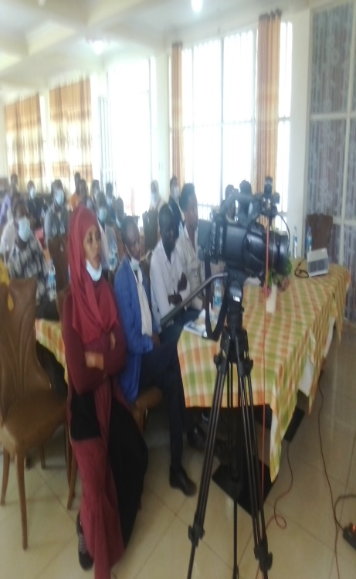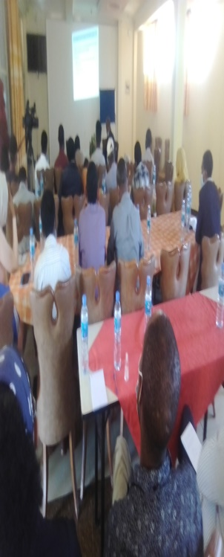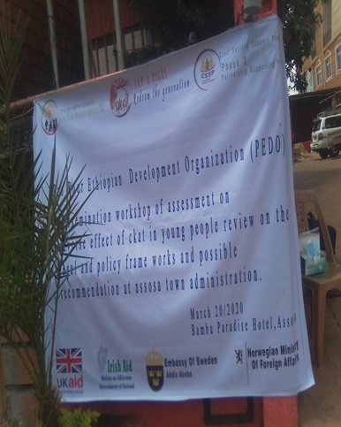
Image 9. Research finding dissemination workshop participants

  - Conduct action research about youth and peace in collaboration with youth clubs to identify their common concern and increase engagement.
The action research about youth and peace in collaboration with youth clubs to identify their common concern and increase engagement entitled ‘’Action Research on Youth Participation in Decision Making, and Conflict Resolution in Assosa City of BGRS’’
at the selected three kebles of Assosa town administration by Assosa University. Currently we have been received the final draft of the action research from Assosa university. Currently we are ready to conduct the validation work shop of the action research.

  - Engage 80 community and religious leaders to disseminate information about the harmful effects of substance abuse

As of Pro Poor Ethiopia have been conducted regular discussions on legal, policy frame works and practice at Assosa city administration on Firs round April 14/2021and second round -27/2021 GC.

. The discussion was focused on the effect of substance abuse that affects the socio economic aspects of youth and the general population of Assosa town administration. The participants were focused on the special solutions of the khat and associated drugs as well as how to prevent and minimize the prevalence of using these drugs. In addition to community and religious leaders the discussion was conducted by JAP committee members, government officials, influential persons youth association members, khat venders, women association members. During the first dissociation session male, 33, women 17 a total of 50and the second 52+50=102participants were attended or participated. The discussion was led by Assosa town administration council speaker atoAlemayehuEmana .

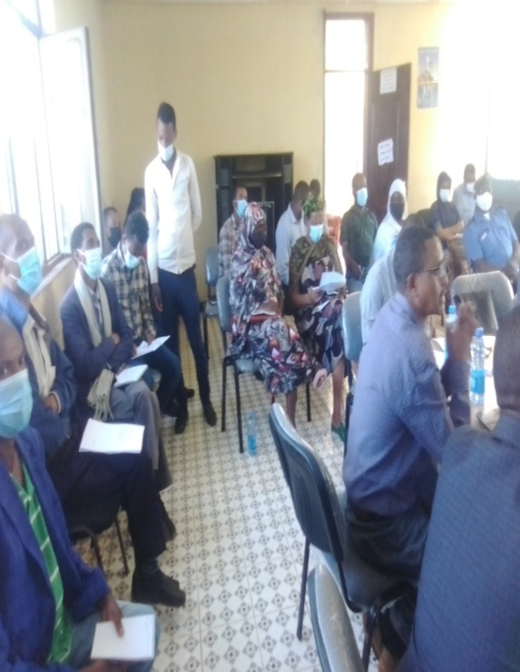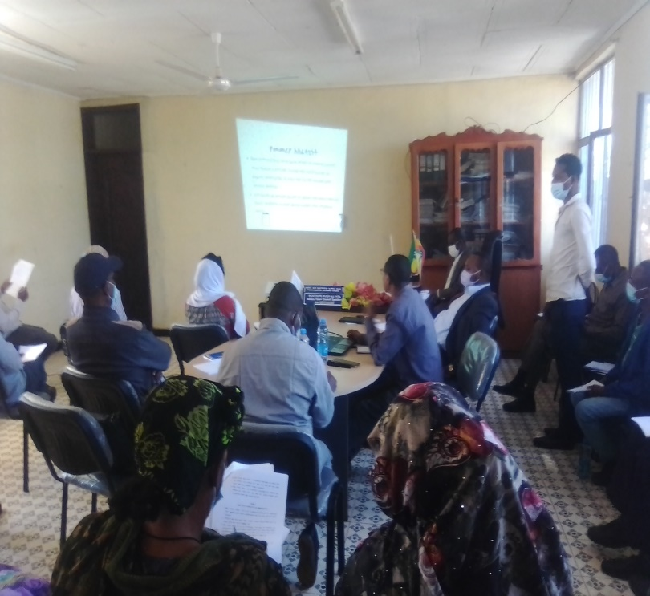
Image 10.Information dissemination program

  - Call for art competition at the regional, zonal and district level, ( initial activity Organize, one annual youth festivals at regional, zonal and district levels to voice their issues, interact and share experience among young people)
We have been conducted Call for art competition at the regional, zonal and district level, ( initial activity Organize, one annual youth festivals at regional, zonal and district levels to voice their issues, interact and share experience among young people. The process of competition was passed different steps , such as we were posted the advertisement at different sights like Assosa University, Assosa use recreation center , different schools, in addition to this we have been also conducted advertisement promotions by using car, montarbo, and professional promoters. The advertisement was stayed for 20 days at to make more visible for competent. Based on this 32 competent have been register for the competition. From 32 competent 10 youths were submitted there pictures to PEDO. At the end of the advertisement period The next activity was verification of the 10 pictures and selecting 3 best pictures proved 1 up to 3 ranking. The selection and evaluation was conducted by three professional evaluator who came from Benishangulgumuz regional state culture and tourism bureau. The selection criteria were conducted by using interview and description of the submitted 10 pictures by the competent.
Lastly the evaluators were selected the three top ranked pictures for the awarded prepared by pro poor Ethiopian Development Organization. During the time of promotion we have been used BenishangulGumuzmas media television and FM radio reporters. Lastly we have been awarded different awards , such as the first ranked competent have been awarded 12birr&certificate, the second ranked picture have been awarded 7000 birr & certificate , the third ranked picture was awarded 5000 birr& certificate. The remaining competent ware awarded participation certificates. When we see the owners of ranked pictures first &second ranked competent were male& the third ranked competent was female. During the promotion program male 21 femal 13 total 34 attendants were participated from the concerned stake holders at Sun sate hotel on April 17/2021.

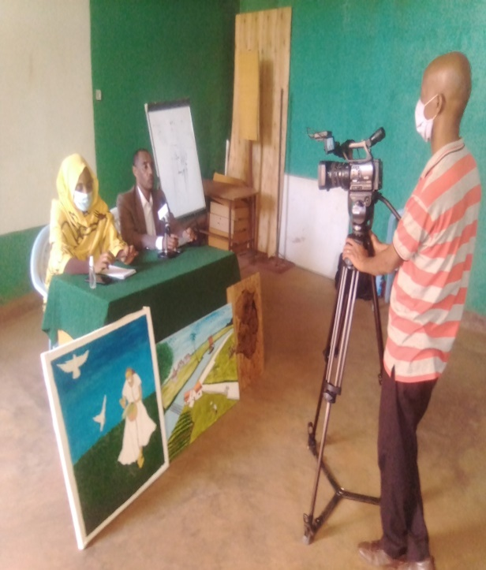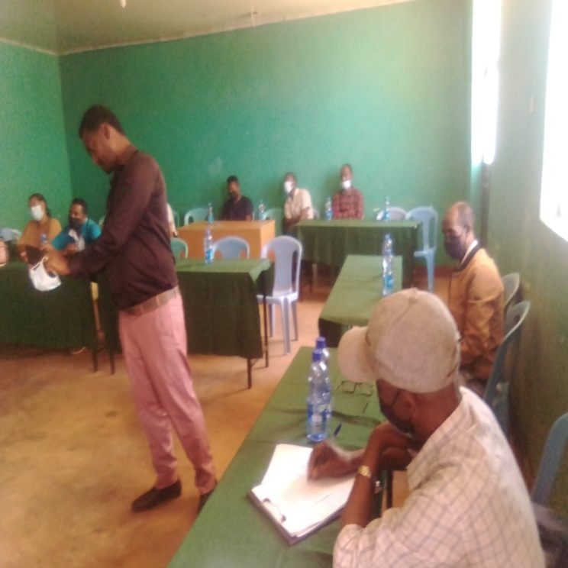
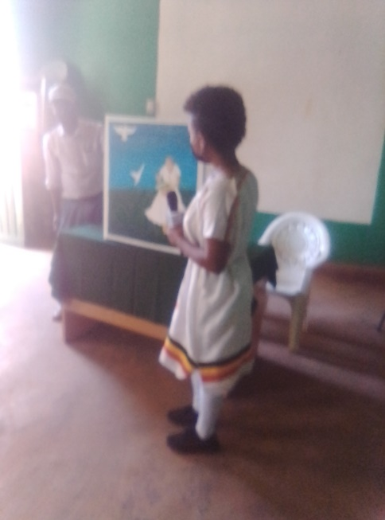
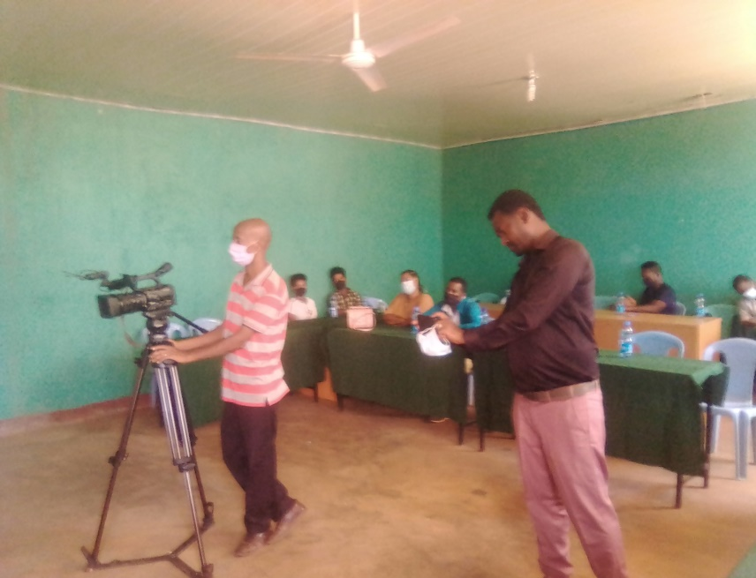
Image 11.Art competition promotion program

  - Provide capacity building training on conflict resolution and peaceful coexistence for 60 young people

Pro Poor Ethiopian Development organization has been conducted capacity building training on conflict resolution and peaceful coexistence for to 60 young people at Assosa youth recreation center on April for male33, female 27 total 60 participants were attended at the training program by two divisions on ------ and ----. The trainer was invited from BenishangulGumuz Regional state peas building bureau.

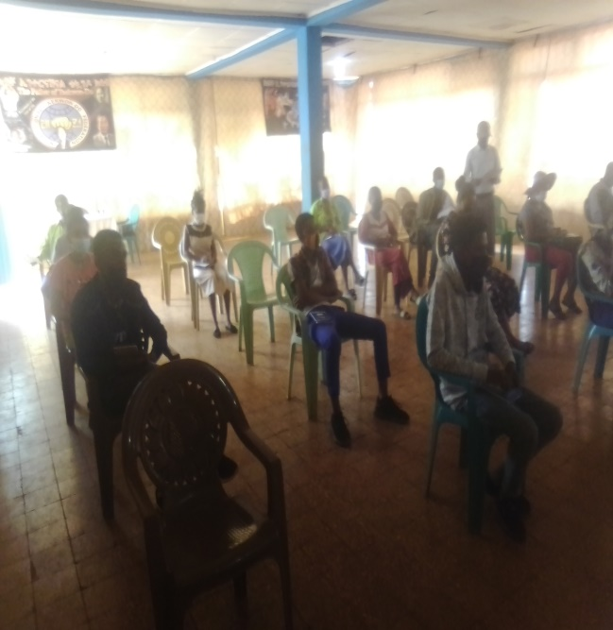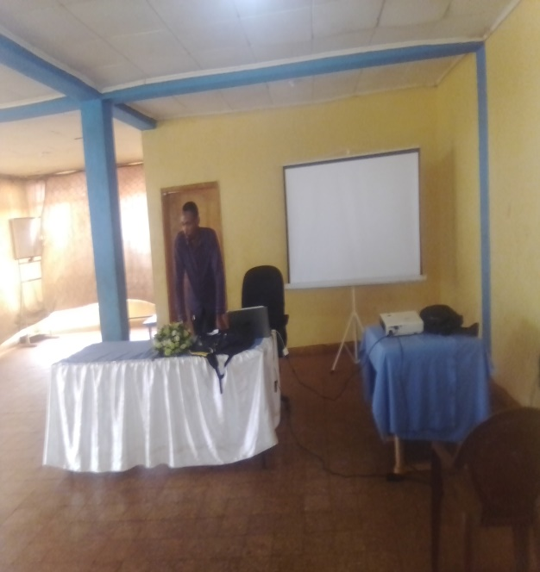
Image 12.capacity building training program

  - Conduct seminars/workshop for 300 policy makers, government partners about the adverse effect of substance abuse
This activity was conducted in collaboration with benishangulGumuz Regional State mass media through television and radio program to deliver the message to the large society by inviting khat users, Government officials, BGDAN and Tesfabilchita charitable organization directors who have matured experiences, young people who are in an addiction youths who were rehabilitated from addiction who can express their ideas on the negative effect of khat and associated drugs on young people.
The program or the documentary film was transmitted for 20 minutes on air on April 27/2021.
2.8Provide active citizenship training for 55 students
This training activity has given to students for about meaning of active citizenship, types of citizenship and usages of citizenship and it takes period of time for three days 28-30/2021.
Challenges
- COVID 19 pandemic: The pandemic challenged us not to conduct our activities on time.
- Low commitment of some stake holders
- Shortage of time to conduct each activity
- The aggravation of COVID19 restricted the mas gathering of our attendants,
Measurements taken for the challenges
- We conducted some of the project activities by contacting our stake holders and project advisory committees individually and by tell phone contact
- We have been conducted our activities by giving priority for the activities that requires more attention
- We have been conducted our programs and different awareness events by inviting medias who to deliver our messages to the mas population.
Lesson learnt
- We have seen the importance of different stake holdersengagement how to implement and to be successfulness of projects.
- Youths are the base of development and peace rather than the base of conflict if we use them properly.
- The success of projects depends on the full engagement of different stake holder.

