PRO POOR ETHIOPIAN DEVELOPMENT ORGANIZTION
ANUAL PERFRRMANC REPORT OF THE YEAR ENDED Dec. 2020

PREPARED BY: Pro Poor Ethiopian Development Organization

ADDIS ABABA
March 2020

Table of Contents
1.Back ground 3
2 Accomplishments by program 4
2.1 OVC and youth support Program 4
2.2.1 Signing project Agreement with concerned Sectors of the region 4
2.2 Comunity embperwmnt 4
2.2.1. Conducting evidence based research 4
2.2.2 Conduct action research about youth 5
2.2..3. Conduct participatory video trainig and consultation meeting 5
2.2.4 Support youth art clubs and associations to engage on prevention and preparedness against the spread of COVID 19 among the general public 6
2.2.5 Community By law 7
2.3.Livelihood Support program 7
2.3.1.Establishment of relief coordination committee 7
4. System strengthening 11
6 Staff recruitment 11
7.Resource mobilization/fund rising 11
.8.. Challenges and solutions to tackle the problems 12
9..Conclusions 12

1.Back ground
Former Pro Poor current Pro Poor Ethiopian Organization (PEDO) was established in June 2003 under the vision “regenerating hope and self esteem” for the hopeless and the disadvantaged communities .Based on the new Civil society Organizations Proclamation No 1113/2019 it is reregistered as Ethiopian Resident Charity Organization in august 2019 with the new name called Pro Poor Ethiopian Development Organization .
Pro Poor has a clear hierarchies of decision making and accountability, The General Assembly is the higher decision making body on constitutions, and policy issues of the organization and approves annual operation plan, budgets, board minutes and audit reports of the organization. It also appoints Board of Trustee to oversee the performance of the organization. The Board of trustee retains the next highest level of authority of which members are working on volunteer basis
The Executive Director is the administrator and manager of the organization. Who leads the two units Program coordination and Finance & administration units . Under program coordination unit there are four thematic areas : Namely HIV and AID Program s, Livelihood Development program,, OVC and youth support program , and finally community empowerment program.; and under Finance and administration unit: there are human resource administration, accounts and general services.
Since its establishment Over 20,000 OVC accessed to basic needs & service ,3500 Older Orphans trained & employed ,Better care & support for PLWHA was provided ,Enhanced capacity of women to generate their own income ,Improved the capacity of Community based structures .Enhanced Awareness on HIV/AIDS prevention & control. we are also well experienced in working with government offices, local administration, grassroots communities, FBOs and CBOs – . The staff of Pp has been rigorously trained in a number of trainings associated with project management, procedures and compliances. Which are added resources to have confidence and trust in Pp’s experience and capacity to managing this project.
It has been working to improve the lives of needy communities particularly children, women and youths, be a voice for voiceless, holistically empowering them to withstand disaster, reduce vulnerability of the affected and infected. . As strategic approach it emphasized community participation and ownership in the real sense of the term, building capacity of wide range local partners & stakeholders, and building strong networking and referral systems with likeminded NGOs, GOs and private entities that shares its vision. The organization has a clearly articulated direction of development and Pro-poor is carrying out its development programme in three regions namely Addis Ababa and Benshangul Gumuze regional regional states of state of Ethiopia . since Its establishment The organization has successfully completed the implementation of 24 projects . During the reporting period the organization has implemented2 different projects on which the report will be focusing on The tiltle of the Projects Implemented during the reporting period are three namely
1.Improving quality of Education in and around assosa town of BenshanguL gumuz
2 Empowering victims of GBVof women and for sustainable economic and social development inworeda 10 of Lideta subcity in AddisAbaba City administration

As a result this report contains performances and achievements of the aforementioned projects during the reporting period in line with the programmatic areas of implementation.

2 Accomplishments by program

The Organization has four thematic areas .Namely RH, HIV/AIDS program, OVC and youth Support program, Sustainable Livelihood Development program and Community empowerment program Instional capacity building pogrames

2.1 OVC and youth support Program

2.2.1 Signing project Agreement with concerned Sectors of the region

In order to implement the project smoothly getting legitimacy and recognition from principal stake holders it has a pivotal importance .Hence after long discussions and negotiations with concerned stake holders of at lideta sub city of Addis Aabab City adminstartion tripartite project agreement was signed in NOV.2022 between and among Lidta subciy administration Finance office , BOLSA and Lideta subcity administration Women Children and Social affairs office on one hand and pro poor on the other hand. ., during the project appraisal process the sectors had made various constructive amendments .

2.2 Community empowerment

2.2.1. Conducting evidence based research

PEDO have been Captured/collect evidence on the adverse effects of substance abuse on young people a case study of targeted project area of Assosa town in collaboration with Aha Consultation P.L.C. This helps us to present the finding of the research to the general public and policy makers about the adverse effects of substance abuse on young pe

2.2.2 Conduct action research about youth
We started a proses with Assosa University to conduct action research to identify their common concern and increase engagement at peace building and conflict resolution as well ass social and economic participation at the two woredas Assosa ton administration of 3 selected ketenas.

2.2..3. Conduct participatory video training and consultation meeting
- We have conducted participatory video training and consultation meeting how to establish addiction rehabilitation center, to prevent the effect of khat and it’s associates on youths and the general public as well as how to ban khat and it’s associate local laws. During the training , male 15, female 10 t0tal 25 participants attended at the training program july 27/2020. were We established addiction rehabilitation creation committee at Assosa town administration level. The committee has 7 male and 2 female a total of 9 members from different concerned sectors, The committee is by Assosa town administration vice mayor. The committee prepared an action plan .

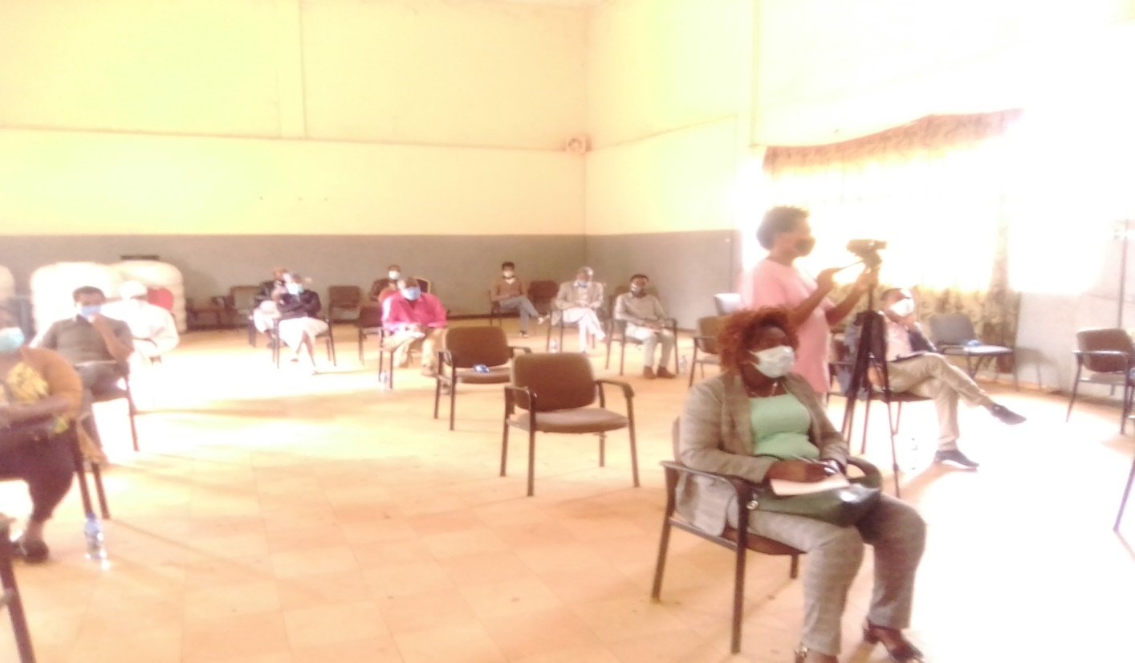

1.4. Establish addiction rehabilitation service improvement center( Committee Joint action plan
- were We established addiction rehabilitation creation committee at Assosa town administration level . The committee has been prepared joint action plan to conduct the following activities,
- To improve youth recreational centers & addiction rehabilitation c enters
- Adopt community by laws of ckat and associate drugs
- To minimize the negative effect of ckat and associate drugs
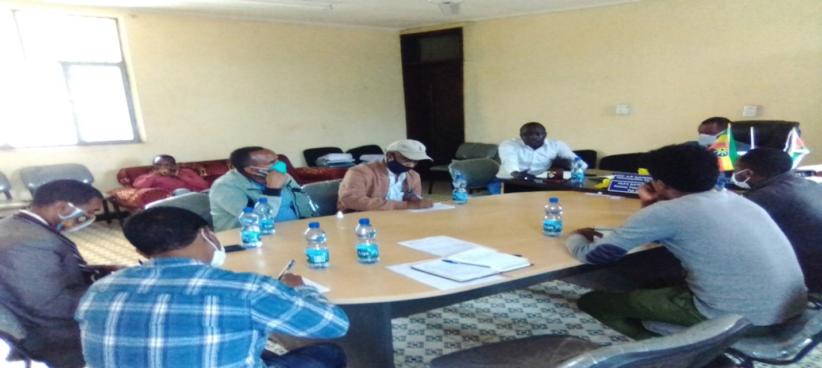

Currently We are giving out patient services for one 11th grade addicted youth in collaboration with Assosa general hospital. He is getting different services like counseling crevice and other addiction treatment services.

2.2.4 Support youth art clubs and associations to engage on prevention and preparedness against the spread of COVID 19 among the general public
Awareness creation was conducted by Zumbara youth vision association and Zumbara youth art club on the influence of khat on prevalence COVD19 as well as peace building mechanisms at Assosa bus station, market places, crowded place where khat and other drugs are mostly used. The awareness creation was conducted by using banners, music Montharbo, mic , video camera and different slogans.
During the awareness raising program male 20 , female 8 total 28 art club members were participated. In addition to the art club members Assosa town administration youth office head and Assosa town administration police members were attended during the program.

2.2.5 Community By law
The JAP committee is actively engaged in a process of crafting anew law to regulate the distribution and consumption of Chat in the town of assosa After a long process the the fisr draft of by law has been developed and presented to the concerned authorities of Asosa city administration ,During the Validation workshop valid inputs were forwarded by the participants and after the in puts were included into the draft by law the final report is waiting for the endorsement by the city council.

2.3.Livelihood Support program

With the fund obtained from AHF emergency fund a the following major activities were performed

2.3.1.Establishment of relief coordination committee
A relief coordination committee composed of 8 members represented from volunteer youth, influential leaders ,kebele administration and Pro Poor Ethiopia was established the , During the fist meeting of of the committee distribution date and place was decided .It was also decided that the distribution to be conducted on 8 Nov.2020 Around Kajnew shale square of Kebele 4 administration of Yeka sub city in Addis Ababa.
One of he major responsibility of the organizing committee was among others selection of 200 target groups taking in to consideration ,douplication of resources, omission ,Persons with disability, helpless edders,of both sexes and child headed families.
2.3 2,Preparation of accessible and safe stores to keep the relief materials until distribution date
Nov.8 was the distribution date .During the distribution invited guests such as representatives of each Kebele admistration were invited and make a few reamks . .

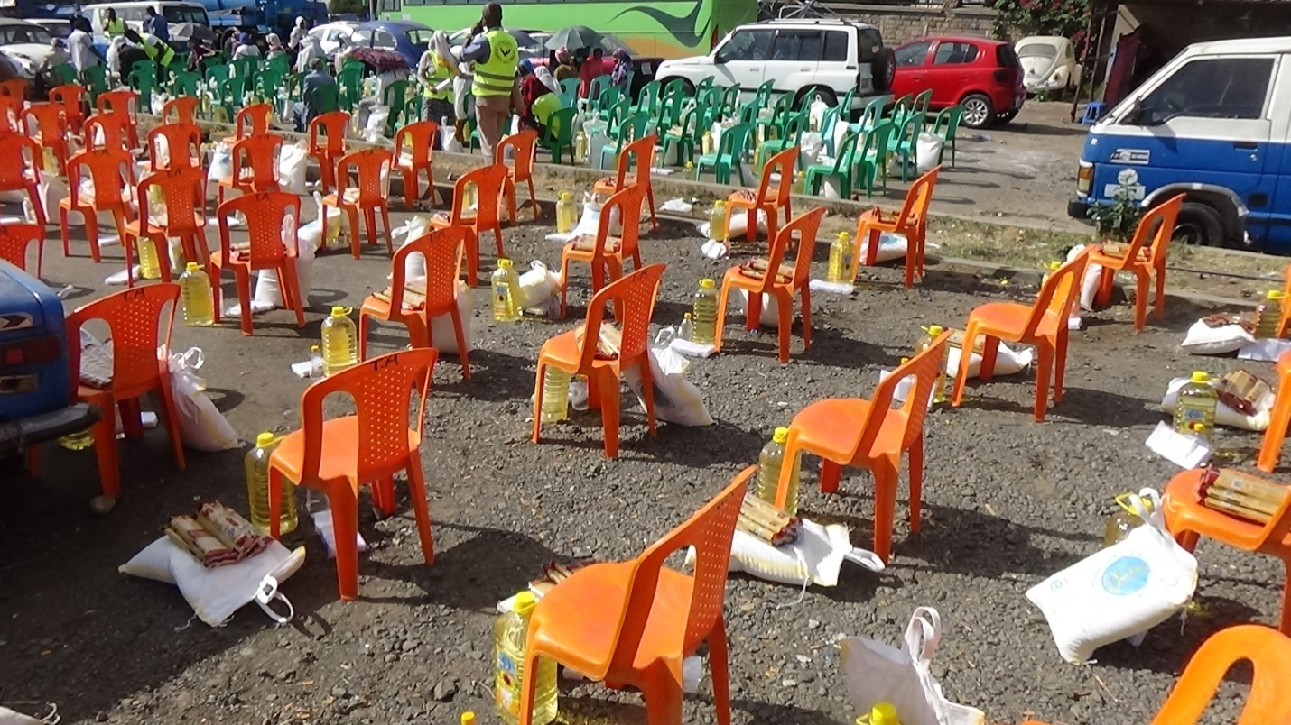
Photo before beneficiaries arrived at the venue (Kagnew Shaleka Squre)Jan Meda area.

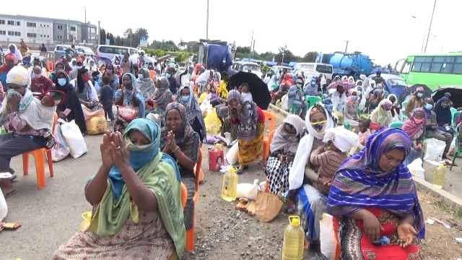
Photo .After Beneficiaries arrived at the venue
ones all beneficiaries and invited guests arrived on the distribution venue a few remaks were made by invited guests . for instance the pholowig photo show the speech delivered by Kebele 4 chief administrator ,
The chief administrator further explained .the magnitude of needy beneficiaries is so huge .It cannot be managed only by government it demands the intervention of civil societies like Pro Poor Ethiopia and AHF Ethiopia. He also expressed that the government is willing to work in close collaboration with such civil societies to reduce and gradually illuminate the shackles of poverty .
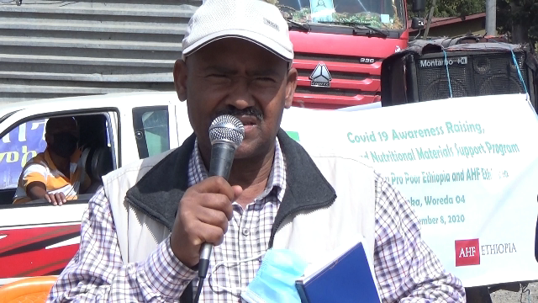
Photo PEDO executive director Mr Gebre Eyesus G.while introducing the objective of the relief support ,where and how the relief support come from and he also briefly introduced the back ground of his organization ,Finally he sincerely thanked to all volunteers,Kebele leaders and beneficiaries as well for their excellent deliberations .he expressed that he is encouraged to invest more in the project area

Representative of Male beneficiaries expressing that the support is received during the most difficult time in their life . specially he expressed his gratitude and happiness to receive relief he blessed by saying god bless you all and the country to be safe and peaceful

Representative of female beneficiaries expressing that relief support is very important to save lives but we need a long lasting support that will ensure our self reliance .

They blessed to the donor and implementing partners. Some of the pictures demonstrate the speech made by the 2(M&F)representatives of Beneficiaries
The types of relif assistance provided to beneficiaries were
Each and every beneficiaries received
10Kg of flour meal
5lites of oil food
2.5Kg pasta
Sanitary materials . such soap and sanitizer was donated.
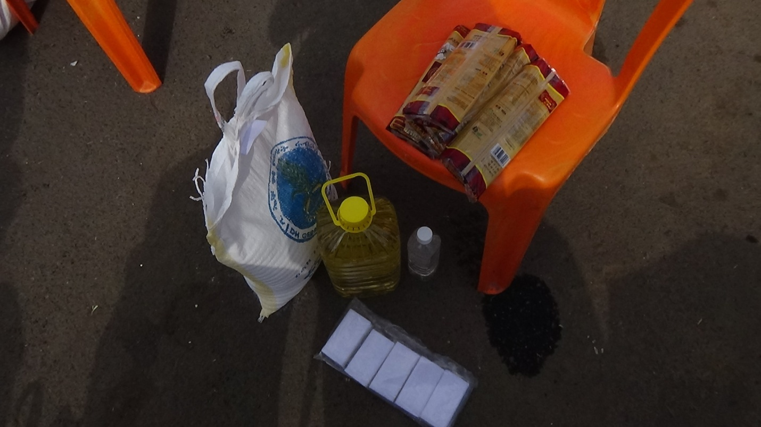
Package of relief support donated to Beeneficiaries
Before and during the distribution of the relief support In poems, songs and music related to COVID 19 prevention was entertained in a form of poems,edutainment program using acar with group ofdjs the awareness raising program was conducted along the major roads and squares of the project where large mass of population was congregated and all people of ages s and sexes has got the chance to leas on massages conducted .
3.Establishment of Safe guarding policy
The basic objective of establishing safe guarding policy to ensure the project has no harm to the project beneficiaries and project experts and he community at large .The project has one safe guarding officer at the project area level. we have also made 3 safe guaring secret boxes and fixed them at two schools and at DEDO Asosa project office .So that it will be able for beneficiaries to make a report secretly when any harm happens to them from any sources.

4. System strengthening

Our Web sight was activated a new a face book account was opened ,
5.. Establishing strong resource mobilization team
During the reporting period We have established two MoUs one with Asosa university and the 2nd Elizier Consulting firm to develop project proposals .Based on the agreenet Asosa Univesity and PEDO has developed 5 project proposal and none of them were rewarded by donors. As at Elizier we were not able to develop proposal collectively.

With in the organization we have also established resource mobilization a team composed of volunteers with diverse professional back grounds including public health ,Economists, development studies ,sociologists with substantial work experiences in different local and international organizations .All volunteers’ are serving the organization on the basis of Voluntarism
All together we have started their business( proposal and concept note development) in form of searching call for proposal posted globally and locally gradually we also developing a resource mapping plan which will indicate to identify the calls proactively world wide .and also to make ready experts who can work on the proposal or concept note in line to their expertise.

6 Staff recruitment
Previously the organization was suffering from lack of the required man power and budget to run and resume its projects and programs both in the head quarter and project areas. .Currently with budget obtained from others donors we are able to re-open our project office in the town of Asosssa and we are able to recruit 4 employees as program and supportive staff for the head off and project are

7.Resource mobilization/fund rising
During the reporting period We have established a MoU with Asosa university and Elizier Consulting firm to develop project proposals .Based on the agreenet Asosa Univesity and PEDO has developed 5 project proposal and none of them were rewarded by donors.As at Elizier we were not able todevelop proposal collectively.

Three diffent volunteers were actively engaed in develong proposal both for global and local call for competitions
We have also other friends and volunteers who provide us timely information about new call for proposal
Generally mare than 15 proposal have been developed and submiteed to donors

.8.. Challenges and solutions to tackle the problems
Lack of budget .It is one of the most outstanding challenge of the organization during the previous physical year we had no new grant secured from donors we were operating our programs with the little budget transferred from the previous year . How ever this year due to the concerted efforts of the secretariat and the board we able to secure small grants from three donors and there are also other donors on the pipe line .

9..Conclusions

The revision of the new CSO law will bring a new opportunity to the NGO sector in general Our organization is planning to make the best from the new legislation by revising its programs and strategies in coherence to the new law. That will allow us to expand our programs coverage in terms of resources and geographic coverage Finally our achievement as compared to the annual operational plan of the organization is far behind to the plan .It is mainly because of lack of budget and corresponding man power as well as logistics .

