
Pro Poor Ethiopian Development (PeDO)

annual narrative and financial report Reporting period from Oct.1 2022 .. March31,2023

Submitted
To
Lideta Subcity Women ,Children and Social Affaires office

By

Pro Poor Ethiopian development organization (PEDO
Addis Ababa, Ethiopia
April , 2023

Contents
1.Background of the organization 3
2.Project back ground 4
3.Performances and Achievements 4
3.1Signing project Agreement 4
3.2 organizing lunching workshop 5
3.3.social and economic empowerment of women and Gils victims of GBA 7
3.3.1Establishing target selection criteria in partnership with stake holders 7
3.3.2 Target selection process . 7
3.3.3 Report on Training for 30 women and girls on developing good entrepreneurship skills and to have accessed for sustainable jobs 8
4 provision of start up capital for selectd women and girls From among the successfully completed training on business planning 10
4.1Petty trade ( Gulit) 10
4.2 Injera Megageria Mitad 10
4.3Traditional bread cooking and saling 11
4.4 Public toilet and bath room 11
4.5Cheeps preparing machine 12
5.conclussions ……………………………………………………………………………………………………………………………………..12

1.Background of the organization

Pro Poor Ethiopian Development Organization is an indigenous NGO, established in June 2003 in Ethiopia. The organization is reregistered as Ethiopian Resident Charity Organization in October 2019. The organization envisions “regenerating hope and self-esteem” for the hopeless and the disadvantaged communities. PEDO is full-fledged member to OVC network Ethiopia, CCRDA (women and girls forum), Basic Education Network Ethiopia, Consortium of Reproductive Health Association (CORHA) and signatory for the Ethiopia NGO code of conduct. PEDO received grants from different donors including USAID, SIDA, Global Fund, WFP, British council, CSSP and HAPCO, AHF ,FFC, are a few to mention.

The organization has also different policies and procedures used to regulate its activities such as SPM active between 2020-2024, financial policy based on IPSAS, Safeguarding policy, Gender mainstreaming policy, HR manual and M&E guideline.PEDO has Established 14 Saving and credit cooperatives directly benefiting over 1750 destitute women and girls, Youth and Persons with disability through revolving fund. The Cooperatives were legally registered .They were working hard to satisfy the immediate and strategic needs of the leaders and members of the cooperatives. PEDO in general works with fighting violence against women and girls in its implementation areas to contribute towards bringing a long-lasting change and improvement in the lives of disadvantaged members of the community with more emphasis on girls, children, women, and youths with more focus on programs aiming at promoting caring for women and girls victims of physical, sexual and psychological violence.

2.Project back ground

The project is supported by Plan Internatgional Ethiopia.The project will address the critical issue of Gender Based Violence (GBV) in woreda 10 of Lidta Sub city of Addis Ababa city administration In order to achieve the stated project objectives PEDO will undertake different activities. Such as conducting Knowledge attitude and practice(KAP) survey of the community on nature and magnitude of Gender Based Violence (GBV) of the target community , Promoting the Major findings of the KAP survey through trainings and Workshops , community based campaigns aimed at awareness creation on gender roles, responsibilities and women rights and the legal frameworks to their rights. through various media of communication such FM radio, Addis Ababa TV ,School mini medias We will develop tailored massages from the recommendations of the KAP survey, , Economic empowerment for gender Based Violence victims of women and girls. The project will directly reach 30 GBV victims through training on Gender justice and Equality ,10 Selected GBV victims through business start up capitals , 30 professional through training on basic skills of counseling, Over 500 students and teacher through school mini medias for the implementation of the project a total of Birr 471,630 is approved from Plan International for a period of 1 year (1OCT 2022.- 30Sept 2023)

3.Performances and Achievements

3.1Signing project Agreement;

The project proposal was submitted to Lideta Zone Finance office and Women Children and social affairs for project a contractual agreement . After a series of consultations and discussions the project agreement was signed on one hand Lideta finance office and Lideta subcitty Women Children and Social affairs and on the other hand Pro poor Ethiopian Development Organization (PEDO) end of Oct.2022using their own formats .During the process of consultation with signatories They appreciated the contents of the proposal but they were also highly concerned about making sure that all activities can be completed with provided small size of the project budget .

3.2 organizing lunching workshop

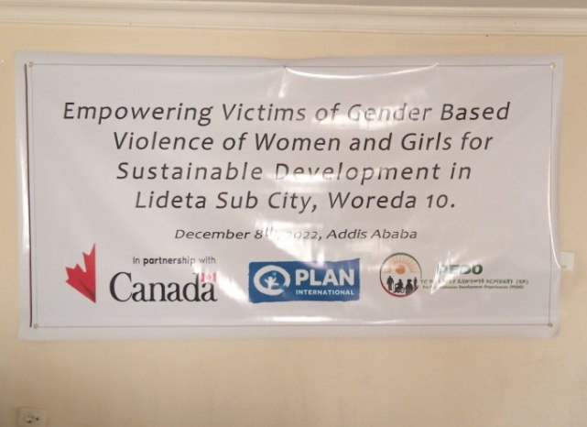

The project entitled Empowering victims of gender based violence of women and girls for sustainable economic and social developments in Lideta sub city of wreda 10 was launched on December 8,2022 at the assembly hall of woreda 10 of Liderta sub city . The launching workshop was conducted respecting COVID19 Prevention protocol .The objective of the workshop was to introduce the objectives ,strategies activities , out comes and out puts of the project and to initiate them to pro actively participate during the project implementation and follow up . During the workshop a total of 30 participants were invited however a total of 28 (F15 and M13) participants attended the workshop .The selection of participants was done by woreda Women Children and Social Affaris office in consultation with PEDO staff. Participants were represented mainly from primary and secondary stake holders through letter of invitation distributed by woeda 10 Women ,Children and social affairs office .the participants were, from Woreda BoH,BoE ,Woreda police from Private sectors ,FBO,CBOS (Youth and Women Associations ) and Schools, are afew to mention .The workshop was officially opened by the guest of honor from Woreda 10 women children and social oaffairs office .During the opening speech she remarked that the project is very relevant and timely to our community and we all stake holders will participate at all stages of the project cycle. And she declared that the project was officially opened

Then after the introduction of the participants was finalized the Mr Gebreyesus G/Michael Executive directore of the NGO made a power point presentation ,The presentation out lined that the project was finically supported by Plan International Ethiopia office for a duration of one year starting from NOct1,2022 –September 30,2023. With atola budgetof471,460 of which 80% was program budget while the remaining 20%is was admin cost. During the power point presentation the the objectives ,the out comes outputs and major activities were introduced . at the end of the presentation various suggestions focusing on the volume of the budget target selection , sustainability and the issue of LGTQ+ were raised and discussed finally All participants appraised the contents of the project and they expressed their readiness and willingness to participate in the in the implementation of the project. the work shop was officially closed by the invited guest from Finance office of Lideta subcity adminstration

3.3.social and economic empowerment of women and Gils victims of GBA

3.3.1Establishing target selection criteria in partnership with stake holders

In order to ensure sustainability and transparency of the project we have established target selection and follow up committee from the community .the committee has 5 members represented from woreda 10 women league ,wreda women association, Medium and micro enterprises ,woreda women children and social affaires office(WCSAO) and PEDO .the committee is chaired by woreda WCSAO and PEDO serves as a secretary. The committee agreed the startup capital would be granted to beneficiaries not in a form of loan nor revolving fund as long as they fulfill the selection criteria they should be granted for free .The committee was loan agreed the grant would be given to beneficiaries not in form of cash but in kind The committee also proposed and agreed the following criteria for selection of beneficiaries .

GBV survivors between the age of 15 and 60

GBV survivors who have working places in their houses or out side their houses .

GBV survivors living with parents or other care takers .

Female commercial sex workers willing to start a new business .Street girls willing start a new business in their community .

3.3.2 Target selection process .

The committee has designed and approved one page a format to register and assess the demographic characteristics of the potential target groups .Then all committee members went o the field to register beneficiaries based on the selection criteria. The committee came up is 50 potential members .in support with documents review from respective offices the committee finally selected 30 beneficiaries and the remaining 20 were registered as reserve in the waiting list ..

3.3.3 Report on Training for 30 women and girls on developing good entrepreneurship skills and to have accessed for sustainable jobs

By the support of plan international Ethiopia. Pro poor Ethiopia development

organization conducted a one day training for 30 women and girls on developing good entrepreneurship skills and to have accessed for sustainable jobs. on small business management for the selected pro poor beneficiaries the details are discussed her under.

Selection of the trainees

The trainees were selected with close collaboration of the government administrative body through serious screening process by going door to door supervision.

Retraining assessment

Before the training, the trainer made assessment about the pre experience of small

business and the challenges they faced while operating the business in their

respective localities (area of business operation). As per the assessment, the

majority (20) among the 28 didn’t practice book keeping, this is to mean that the

majority not familiar with the practice of expanse &profit ; revenue calculating practice that lead them for failure. The Second assessment demonstrates that capital shortage for expanding their business was the major challenges.

. Content of the training

Concept of small business

Type of small business

Challenges of small business

Book keeping over view

Importance of book keeping In business operation

Customer management In business operation

Quality of business Operators Customer management

Success faction of business Operation

Faithless factors in business Operation

Methodology

The training sessions put into practice the following methodology to achieve the

Training objectives

Presentation

Group discussion

Case study

Experience sharing

Output of the training .Totally 38 pro poor participates pass through the training acquired necessary skills and knowledge on small business management

4 provision of start up capital for selectd women and girls From among the successfully completed training on business planning

it was planned that 10 beneficiaries would be granted start up capita from the project . how ever the committee has conducted a rapid needs assessment and market assessment of beneficiaries .based on the findings of both assessments the committee decided to support more than 10 individuals who can fulfill the selection criteria. The start up capital was granted to beneficiaries in the following manner .

4.1Petty trade ( Gulit)

According to the assessment most of them were found to be sexually abused .One of the beneficiary has a child out of wedlock .where abouts of the father is not known the child is named by her fathers name. most of them are suffering from stigma and discrimination due to esexual abuse .They don’t wont to tell what happed to them in detail. 8 beneficiaries who were working at Gulit were supported through start up capital The working place was offered to them by kebele adminstartion before the intervention of our project but due to lack of capital they were not working at full capacity . According to the findings of the need assessments they need to increase the variety and quantity of the commodity . To this effect each of them were provided 4000 ETB in cash to expand and promote their business. Most of the beneficiaries are engaged in distribution of vegetables ,spices, cooking coffes are afew to mention .

4.2 Injera Megageria Mitad

The second type of beneficiaries were engaged at injeara preparation and saling They had no previous experience of doing business .but after participation of the entrepreneurship training they were motivated to start a new business at home hence 3 women demanded the project to provide them Injera Megageria Mitad basesd on their felt need we provide them injer megageria mitad working with electric power at accost of 5000 ETB each . which can produce more quality injera in a short time to the market . Hence A new business opportunity was created for 3 women bread winners who also victims of GBV. Now they are able to generate income to themselves and their family at large .Raw materials such as Tef for injera making were collected from the near by flour mill owners in credit market linkage was also created with buyes .

4.3Traditional bread cooking and saling

As per the findings of the needs assessment 5 beneficiaries prioritized for Dabo Megaggeria machine . One of them is determined to change here livelihood from commercial sex work to bread beaking and selling If she is provided Dabo Megaggeria machine . The other beneficiary was also street girl she was exposed to smoking sigarate, chewing chat and also alcohol drinks, he has 4 children all of whom were born from different fathers through sexual abuse. The other remaining beneficiaries have also sad stories related to GBV. Fortunately most of them have little experience doing business . such as Petty trade including buying and selling Traditional bread from whole sellers hence Their first priority were to be engaged in bread preparation and selling . and the beneficiaries first priority is to get Dabo Megageria Machine once we make sure that all of them are living in a rented house from the kebele administration having access to electric power and water supply , we provided them moden dabo megageria machine at accost of 9000 ETB each.to this effect 5 beneficiaries were provided modern dabo megageria machile at a total cost of 45,000 EBT

4.4 Public toilet and bath room

8 beneficiries working in two cooperatives (5 and 3) are engaged in public bath room. . Previoisly the bath rooms were not well furnished to this effect both bath rooms were not working at full capacity .The major limitation of the bath rooms as per the findings of the assessment is lack of access to electic power.And all beneficiaries demanded to the project to create accesses to electric power so as to provide hot water bath services to their clients . Hence the project has created access to electric power and boiler and other relevant accesserories For two public bath rooms each bath room has 8 doors serving a total of 16 clients at the same time paying service charge of 10 ETB . at once Hence the daily income of the 8 GBV survirores and other non GBV survivors daily income will be improved significantly . It will also contribute for the improvement sanitation of the community dwellers The community will receive quality services in their vicinity

4.5 Cheeps preparing machine

One beneficiaries have preferred to be engaged in chips preparation and saling to the community . Hence one beneficiary was granted one modern Chips roasting machine at accost of 6000 ETB

5. Conclusion
we have planed three activities Signing project agreement , project launching to stake holders one day training for 30 women and girls on developing good entrepreneurship skills and to have accessed for sustainable jobs and provision of start up capitals for 10 out standing trainess and all of them are done. Stake holders Participation was encouraging. specifically woreda Women ,Children and Social affaires office participated in availing venue for the workshop selection of launching work shop participants and distribution of invitation letters to participants . Establishing target selection and supervision committee responsible to select target groups for Start up capitls ,proposing and endorsing target selection criteria and to oversee the smooth implementation of the project are a few to mention .One of the significant achievements of the project is, it was planned to provide startup capital for 10 beneficiaries but due to the rapid needs assessment of the target group and market assessment to purchase capacity building materials to be provided to target enabled us to increase our achievements . we did not face a strong challenge . From our internal monitoring We have learned that one of the major problem of the project area is un employment followed by housing problems..Our partners at zonal and woreda level have well come our proposal for entailing IGA to address the unemployment issue of the target area. We have also leaned that participation of stake holders in drafting target selection criteas for IGA beneficiaries and establishment of target selection and follow up committee from among the stakeholders has significant contribution to develop trust and confidence among stake holders

Annexe No 1 list of beneficiaries
1.List of beneficiaries who received start up capital in woreda 10

1.1 list of Petty trade (Gulit ) beneficiaries
Name Cell phone
1.Beletu Molla 0910434108
2,Yehalawork shewa kena 0932152794
3.Asresash Asefie 0995112991
4.zinash Mesfin 0909116077
5.Abebu Kebebew 0921921924
6.Birtukan Woldie 0922117164
7.Truye Dagne 0921318212
8 Feven Getnet 0993099495

1.2 List of Beneficiaries who received Ingera megageria Mitad
Name cell phne
1. Tejitu Abiyu 0985201551
2 Tigist Baisa 0932518425
3.Birhane Gebre 0909775356

1.3 List of Beneficiaries who received Dabo megageria Machile
Name Cell phone
1.Mulu Getachew 0912178646
2.Meseret Getachew 0920639735
3.Anchnesh Tsegaye 0939879340
4.woinshet Temesgen 0901095416
5.Selamnesh terefe 0911126992

1.4 name of beneficiary who received cheeps roasting machine
Name cell phone
1.Etaferahu Shiferaw 0906464226
2 public latrine and shower share companies were also were accessed with electric power ,Boiler and other accessories as mentioned below
2.1 Zenebech Tafese and friends shower and latrine share company
Name of beneficiaries Cell phone
1.Zenebech Tafesse manager (representative) 0929175846
2.Yeshi lakew Beshah
3.Asnkch Fuji
4.Afrasa Tadesse
5.Rehima Awol
2.2 Genet wolansa and friends shower and latrine share company
The share company was accessed with electric power and other accessories from the project
Name of beneficiaries Cell phone
1.Genet Sherif manager and representative 0983755322
2.Wolansa Gebre amlak
3.gene gelaw
A total of 25 beneficiaries have been benefited from the project through start up capital

Annex No 2 Different photos cuptured at different events of the project

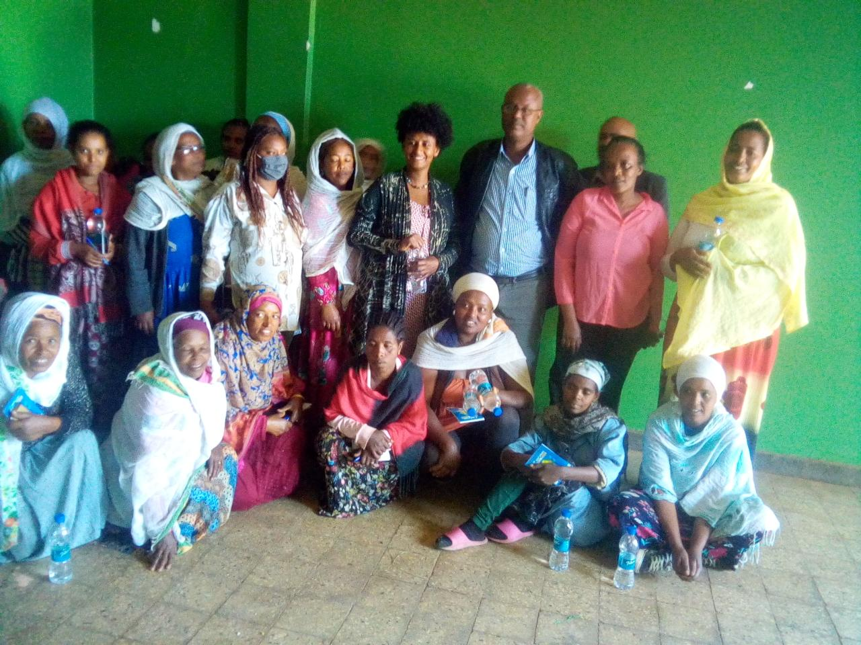
Group photo of the local management representatives trainer ,trainees and project management and staff

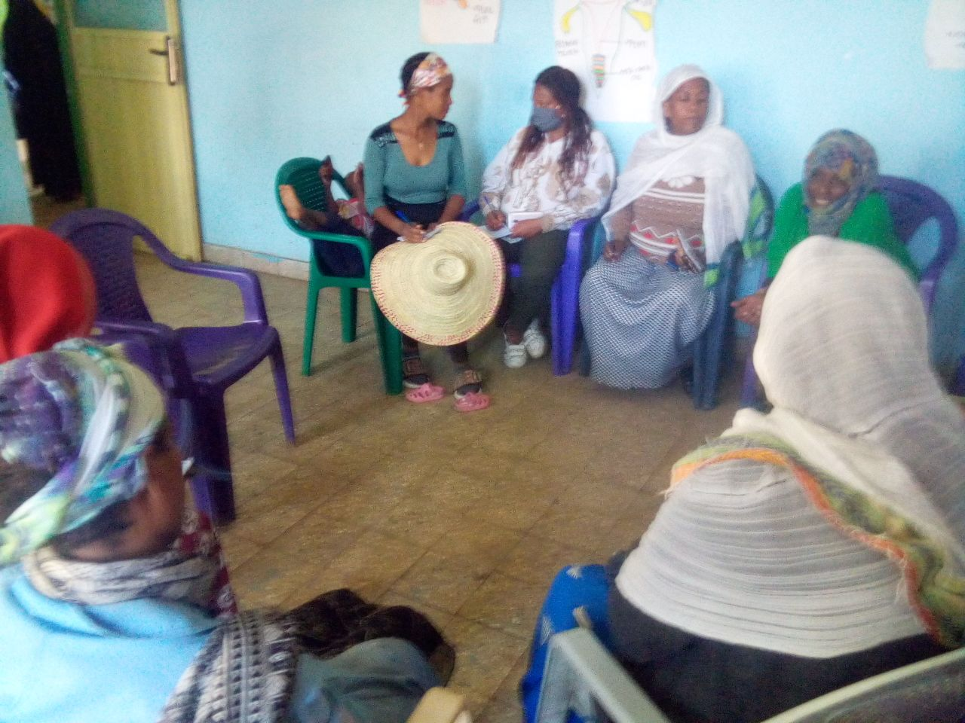
Group work discussion

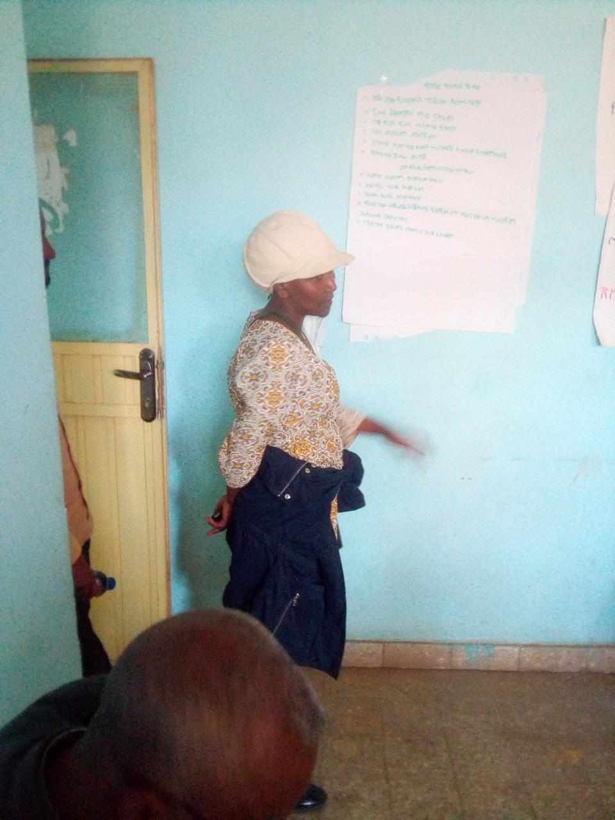
Presentation of group work by group representatives

Pictures captured during the handing over of the materials

